

**School of Art and Creative Technologies**

**M.Sc. Cloud Computing and Network Security**

**University of Bolton**

**Securing IoT Networks with Advance Threat Detection Through Machine Learning Technique**

Prepared by Adedapo Paul Aderemi

Student ID: 2228182

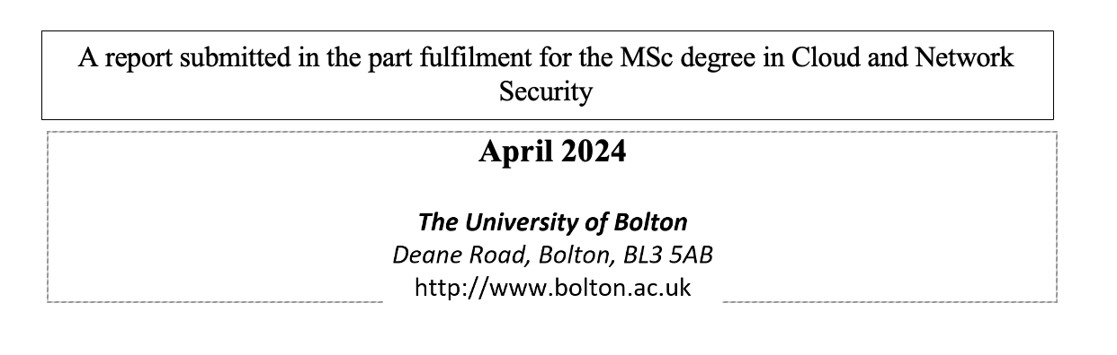

**Dedication**

This thesis is dedicated to all those who tirelessly pursue love and peace in our world. Your unwavering commitment to understanding, empathy, and cooperation serves as a beacon of hope amidst turbulent times. May your efforts continue to inspire positive change and foster harmony across borders and ideologies.

I also dedicate this work to the relentless spirit of researchers everywhere. Your dedication to uncovering knowledge, pushing boundaries, and seeking truth enriches our collective understanding of the world. May your curiosity and perseverance continue to illuminate the path toward a brighter future for all.

**Acknowledgement**

I would like to express my deepest gratitude to the Almighty God for granting me the strength, wisdom, and guidance throughout this journey. Your divine presence has been my constant source of inspiration and solace.

To my beloved family, thank you for your unwavering love, support, and encouragement. Your belief in me has been the driving force behind every step of this endeavour. I am endlessly grateful for your sacrifices and understanding.

I owe a debt of gratitude to my supervisor, Dr. Celestine Iwendi, whose expertise, guidance, and unwavering support have been invaluable. Your mentorship has shaped not only this thesis but also my academic and professional growth.

Special thanks to Pastor Timothy Ojotisa for his boundless love, care, and teachings. Your spiritual guidance and encouragement have been a source of strength and clarity throughout this journey. Your presence has been a constant reminder of the importance of faith and perseverance.

**Abstract**

This research presents the development of an advanced Intrusion Detection System (IDS) using a hybrid machine learning model that combines and compares various Ensemble methods like combing Random Forest (RF) and Deep Neural Network (DNN) techniques. The aim is to enhance threat detection capabilities in IoT networks by leveraging the CICIoT2023 dataset, a comprehensive and realistic dataset that closely mimics real-world IoT environments. The key objectives of the research are: 1) to create a robust and resilient IDS by harnessing the strengths of ensemble methods and deep learning, 2) to improve the accuracy and efficiency of detecting various attack types such as DDoS, Reconnaissance, and Cross-Site Scripting, and 3) to contribute to the advancement of IoT security research through practical application and evaluation of the developed IDS. The methodology involves a systematic approach, including data pre-processing, feature engineering, model development, and performance evaluation. The pragmatic research philosophy combines positivist and interpretivist perspectives to address the technical and contextual aspects of cybersecurity. The results demonstrate the effectiveness of the hybrid ML model in outperforming individual techniques, highlighting its potential to enhance intrusion detection in IoT networks. The study concludes by discussing the practical implications and future research directions in the field of IoT security.

**Keywords** –Machine Learning (ML), Ensemble, Hybrid, Intrusion Detection System, Internet of Things (IoT), CICIOT2023 Dataset, Security

**Table of Contents**

Chapter 1 -Introduction 11

1.1. Background to the Study 11

1.1.1. Intrusion Detection Systems (IDS) in IoT 13

1.1.2. Types of Intrusion Detection Systems: 13

1.1.3. Dataset Overview 14

1.1.4. CICIoT2023 Data collection Methodology. 16

1.1.5. CICIoT2023 Benign data generation 17

1.1.6. CICIoT2023 Recorded attacks 18

1.2. Problem Statement 20

1.3. Aim, Objectives, and Purpose 21

1.3.1. Aim 21

1.3.2. Objectives 22

1.3.3. Purpose 23

1.4. Research Questions 23

1.5. Significance of Study 24

1.6. Scope and Limitations of Study 24

1.7. Thesis Organisation 25

Chapter 2-Literature Review 27

2.1. Introduction 27

2.2. The progression of researcher on IoT security 27

2.2.1. Prominent Themes in the Literature on IoT Security 27

2.2.2. Current Developments and Obstacles 28

2.3 Literature Review Table 28

2.3.1. Research Question 1 33

2.3.2. Answer 1 33

2.3.3. Research Question 2 33

2.3.4. Answer 2 33

2.4. Gaps in existing body of knowledge. 35

2.5. Conclusion 35

Chapter 3 – Methodology 37

3.1. Introductory 37

3.2. Research Philosophy 37

3.3. Proposed Workflow 38

3.3.1. IoT Network and Vulnerabilities 39

3.3.2. Data Understanding 40

3.3.3. Dataset 42

3.3.4. Data Pre-processing 44

3.3.4.1. Data Cleaning 44

3.3.4.2. Data Splitting for the Hybrid Model Training and Evaluation 45

3.3.5. Training and Validation 46

3.3.6. Testing and Evaluation 46

3.3.7. Comparative Analysis 47

3.4. Research Method 47

3.5. Research Design 48

3.6. Data Analysis Plan 48

3.7. Machine Learning 48

3.7.1. Introduction 48

3.7.2. Ensemble Methods in Machine Learning 48

3.7.3. Random Forest (RF) 49

3.7.4. Ensemble Voting Method 49

3.7.5. Random Subspace Method 50

3.7.6. Bayesian Model Averaging 50

3.7.7. Deep Neural Network (DNN) 50

3.8. Ethical Concern 51

Chapter 4 – Implementation and Results 52

4.1. Introduction 52

4.2. Proposed Solution 52

4.2.1. Integration of RF and DNN 53

4.2.2. Implementation Strategy 54

4.2.3. Evaluation and Optimization 54

4.3. Data Pre-processing 54

4.3.1. Data Cleaning 55

4.3.2. Data Transformation 56

4.3.3. Subset Selection and Model Training 58

4.4. Result Analysis and Evaluation 59

4.4.1 Model Performance Metrics 59

4.4.2. Random Forest 59

4.4.3. Deep Neural Network 61

4.4.4. Ensemble Voting Method 63

4.4.5. Ensemble Random Subspace Method 65

4.4.6. Ensemble Bayesian Model Averaging 67

4.4.7. Ensemble Boosting 69

4.4.8. Model Comparison. 71

4.4.9. Visual Representation 75

4.5. Deployment 76

4.5.1. Research Question 3 76

4.5.2. Answer 3 76

Chapter 5 - Discussion 78

5.1. Effectiveness of Machine Learning Models 78

5.2. Strengths and Weaknesses of ML Approaches 78

5.3. Challenges and Opportunities in IoT Security 79

5.3.1. Dynamic and Heterogeneous Data Streams 80

5.3.2. Resource Constraints on IoT Devices 80

5.3.3. Privacy and Ethical Concerns 80

5.4. Implications for Practice and Policy 81

Chapter 6 – Conclusion and Future Work 83

6.1. Conclusion 83

6.2. Limitation of Study 83

6.3. Future Work 83

References 85

Bibliography 89

Appendix – Project Timeline 90

Appendix - Code 92

**PRESS F9 TO UPDATE THE CONTENTS PAGE (this is non-printing text)**

**List of Tables**

Table 2.1: An overview of academic publications and their relevance to research. 29

Table 3.1- Percentage and count of various attack types within the CICIoT2023 dataset 41

Table 3.2- CICIoT2023 Dataset Feature description 43

Table 4.1 Random Forest Evaluation result 60

Table 4.2 DNN evaluation result 62

Table 4.3 Ensemble Voting Method Evaluation result 63

Table 4.4 Ensemble Random Subspace Method Evaluation result 66

Table 4.6 Ensemble Bayesian Model Averaging Evaluation result 68

Table 4.8 Ensemble Boosting Evaluation result 69

Table 4.9 Different model evaluation results 72

**List of FIGURES**

Figure 1.1 An illustration of interconnected devices across different sectors. 12

Figure 1.2 Illustration of the methods used by CICIoT2023 in producing their dataset. 17

Figure 1.3 The significance of this study 24

Figure 2.1- Illustration of the attack method used for CICIoT2023 dataset. 34

Figure 3.1-Proposed workflow for the hybrid ML model in an IoT environment. 39

Figure 3.2 - Distributions of the types of attacks records. 41

Figure 4.1 Data cleaning process and results. 56

Figure 4.2 Data transformation and output 58

Figure 4.3 - Random Forest classifier’s confusion matrix 61

Figure 4.4 - Confusion matrix of DNN classifier 63

Figure 4.5 - Voting method classifier confusion matrix 65

Figure 4.6- Confusion matrix of the Random Subspace classifier 67

Figure 4.7- Confusion matrix of the combine RF and DNN classifier using Bayesian averaging. 69

Figure 4.8 - Adaboost classifier confusion matrix 71

Figure 4.9 - Bar chart representation of the different algorithm accuracy. 76

**List of Abbreviations**

ACK Acknowledgement

AI Artificial Intelligence

ANN Artificial Neural Networks

CIC Canadian Institute for Cybersecurity

CICIoT2023 Canadian Institute of Cybersecurity Internet of Things Dataset 2023

DDoS Distributed Denial of Service

DNN Deep Neural Network

HIDS Host-based Intrusion Detection Systems

HTTP Hypertext Transfer Protocol

ICMP Internet Control Message Protocol

IDS Intrusion Detection Systems

IoT Internet of Things

IP Internet Protocol

ML Machine Learning

NIDS Network-based Intrusion Detection Systems

OS Operating System

PCAP Packet Capture

PSH-ACK Push-Acknowledgement

RST-FIN Reset-Finished

RF Random Forest

Recon Reconnaissance

SQL Structured Query Language

SYN Synchronize

TCP Transmission Control Protocol

UDP User Datagram Protocol

XSS Cross-Site Scripting

# Chapter 1 -Introduction

The chapter introduces the need of securing Internet of Things (IoT) networks against changing cyber threats. This chapter attempts to provide the groundwork for creating a robust intrusion detection system (IDS) through the exploration of IoT security concerns, the importance of IDS, and the capabilities of machine learning (ML) techniques. This research aims to improve threat detection capabilities and advance IoT security practices using the Canadian Institute of Cybersecurity Internet of Things 2023 (CICIoT2023) dataset. It tries to tackle the challenges of protecting IoT networks and reducing risks related to intrusions using a systematic method.

## Background to the Study

The swift increase in IoT devices has transformed our interaction with technology, allowing for smooth connectivity and automation in sectors including healthcare, smart homes, industrial automation, and transportation systems (Al-Fuqaha et al., 2015). IoT devices consist of several networked sensors, actuators, and smart devices that gather and share data to facilitate intelligent decision-making and automation. Yet, this interconnection also brings up notable security issues, since IoT networks are susceptible to numerous cyber risks and assaults because of their dispersed structure, varied communication protocols, limited resources, and absence of standardised security measures. Figure 1.1 shows a diagram of the integrated IoT ecosystem, demonstrating the smooth communication across different sectors including healthcare, household automation, industrial control, and vehicular networks, all connected by advanced IoT infrastructures.



Healthcare

IT Infrastructures

Sport

Education

Constructions  
&

Buildings

Manufacturing

Aviation

Security

IoT

Figure 1.1 An illustration of interconnected devices across different sectors.

Recently, the security of IoT networks has become a significant issue for researchers, industry professionals, and regulators. The distinct features of IoT settings, such diversity, scalability, mobility, and dynamism, present intricate obstacles for safeguarding the confidentiality, integrity, and availability of data sent and handled by IoT devices (HaddadPajouh et al., 2021). Conventional security methods are frequently insufficient to deal with the changing threats in IoT environments. There is an urgent requirement for advanced security solutions that can efficiently identify and reduce cyber threats in real-time to protect the integrity and operation of IoT devices.

IDS are crucial for improving the security of networked systems by monitoring network traffic patterns, detecting abnormal behaviour that may signal security breaches or intrusions, and activating prompt responses to reduce risks (García-Teodoro et al., 2009). IDS may be categorised into two primary groups: signature-based detection and anomaly-based detection. Signature-based Intrusion Detection Systems (IDS) use predetermined patterns or signatures of known attacks to identify malicious activities. In contrast, anomaly-based IDS utilise ML algorithms to analyse typical network behaviour and identify variations that might signal suspicious or malicious activity.

ML are being used in intrusion detection because they can analyse intricate patterns from extensive datasets and adjust to changing threats instantly. Utilising neural networks' parallel processing capabilities and feature extraction from raw data, IDS powered by ML can improve threat detection accuracy and efficiency in IoT networks. Neural networks may learn to distinguish between normal and harmful activity by being trained on labelled datasets that include instances of both forms of behaviour.

The CICIoT2023 dataset is a helpful resource for academics working on developing and accessing IDS in IoT contexts (Neto et al., 2023). The dataset contains real-time IoT attack data gathered from several sources (about 105 IoT devices) in a simulated IoT network setting. Researchers may evaluate the effectiveness of their algorithms in identifying common attack types like Denial of Service (DoS), Distributed Denial of Service (DDoS), Reconnaissance (Recon), Cross-Site Scripting (XSS), Mirai, Brute force, Spoofing and more by using the CICIoT2023 dataset for training and testing IDS models.

Ultimately, the growing use of IoT devices in many industries requires strong security protocols to safeguard against cyber-attacks and maintain the durability of IoT networks. Researchers may enhance IoT security and reduce hazards in linked environments by creating an IDS utilising hybrid ML model and the CICIoT2023 dataset.

### Intrusion Detection Systems (IDS) in IoT

IDS are essential for protecting IoT networks from unwanted activity by monitoring network traffic patterns and detecting security breaches in real-time. Multiple types of IDS exist, each employing unique methods to identify unauthorised access in IoT settings.

### Types of Intrusion Detection Systems:

1. Network-based Intrusion Detection Systems (NIDS) scan network traffic to detect suspicious patterns and abnormalities. The categories can be divided into promiscuous and network system modes according to (Mishra et al., 2023).
2. Host-based Intrusion Detection Systems (HIDS) concentrate on specific devices or hosts in the network by examining system logs and activity to identify unauthorised access or unusual behaviour (Kizza, 2024).
3. Signature-based Intrusion Detection Systems (IDS) detect harmful activity by matching them against predetermined patterns or signatures of known attacks. Although they are efficient in countering established threats, they may have difficulties in identifying new or zero-day assaults (Mishra et al., 2023).
4. Anomaly-based Intrusion Detection Systems (IDS) use ML methods to create a model of typical network behaviour and identify variations that might suggest potentially malicious activity. These systems can adjust against new threats and changing attack patterns by studying past data (Patidar et al., 2020).

Utilising Artificial Intelligence (AI) and ML methods has demonstrated potential in improving the functionalities of IDS in IoT settings. ML-based IDS can enhance detection accuracy and efficiency by training models on labelled datasets that include normal and malicious activity (Kilincer et al., 2021).

Challenges including alert fatigue, false positives, and evasion strategies continue to be common in IoT security despite developments in IDS technology (Domb et al., 2023). Future research aims to build more resilient and flexible intrusion detection algorithms specifically designed for the ever-changing nature of IoT ecosystems.

Deploying efficient IDS in IoT networks is crucial for reducing the vulnerabilities to cyber-attacks and safeguarding the security and reliability of associated devices. Researchers can improve threat detection capabilities and bolster the resilience of IoT systems against intrusions by studying various IDS types, such as signature-based and anomaly-based methods, and using ML techniques.

### Dataset Overview

The CICIoT2023 dataset is important because it has effectively recorded several sorts of attacks frequently found in IoT environments, such as DoS, DDoS, Recon, and XSS and many others. These dataset covers a variety of attack scenarios, allowing researchers to investigate different threat vectors and create strong IDS designed to address the unique problems presented by each type of assault.

1. DoS and DDoS attacks: These attacks include flooding a target system or network with excessive traffic to make it unavailable to legitimate users (Somani et al., 2017). Researchers may analyse the features and trends of DDoS assaults by using DDoS attack data in the CICIoT2023 dataset, which can help in creating efficient mitigation techniques.
2. Reconnaissance attacks entail investigating a target network to collect data about its layout, weaknesses, and possible ports of entry for exploitation (Chen et al., 2020). The inclusion of Reconnaissance attack data in the CICIoT2023 dataset allows researchers to analyse the strategies employed by threat actors at the beginning of an attack, improving threat intelligence and proactive security measures.
3. XSS Attacks include exploiting weaknesses in web applications to insert harmful scripts into legitimate websites, which can lead to the compromise of user data or the execution of unauthorised operations (Gupta and Gupta, 2017). Researchers may analyse the effects of XSS attacks on IoT devices and create strategies to reduce XSS vulnerabilities by including XSS attack data in the CICIoT2023 dataset.
4. Spoofing attacks involve an attacker disguising themselves as a legitimate entity to deceive victims into granting access or divulging sensitive information. This can occur across various channels, such as email, caller ID, and IP addresses, exploiting the inherent trust in communication systems. The goal is often to steal data, spread malware, or commit fraud. Effective countermeasures include scepticism towards unsolicited communications and the use of authentication and verification technologies to prevent unauthorized access (Babu et al., 2011).
5. The Mirai botnet, identified in 2016, represents a significant threat in the IoT landscape, exploiting weak security on devices like cameras and routers to launch massive DDoS attacks. By infecting these devices, Mirai was able to disrupt major internet services, showcasing the vulnerabilities in IoT security. The release of its source code has led to various iterations, emphasizing the need for stronger security practices, including changing default credentials and updating firmware regularly (Antonakakis et al., 2017; Zhang et al., 2020).
6. Brute force attacks systematically guess passwords or encryption keys until the correct one is found. This method targets weak passwords, exploiting the lack of complexity to gain unauthorized access. The study of real-world password vulnerabilities highlights the effectiveness of combining brute-force with dictionary and hybrid attacks. Protecting against these attacks requires the use of strong, complex passwords, implementing account lockout mechanisms, and employing multi-factor authentication (Bošnjak et al., 2018; Grover and Gagandeep, 2020.)
7. Web-based threats exploit vulnerabilities in web applications to compromise security and privacy. These threats include phishing, drive-by downloads, and cross-site scripting (XSS), leveraging the widespread use of the internet to target a broad audience. The complexity and variety of web-based threats necessitate a multi-layered defence strategy, including regular software updates, the use of reputable antivirus solutions, and educating users on safe browsing practices to mitigate the risk of attacks (Sathaye et al., 2022).

The CICIoT2023 dataset provides a wide range of attack data, enabling researchers to do thorough studies, assess the effectiveness of intrusion detection systems, and improve cybersecurity measures in IoT settings. Researchers may use this information to uncover new risks, recognise trends that suggest malicious behaviour, and confirm the efficacy of security solutions created to safeguard IoT networks from cyber assaults.  
The CICIoT2023 dataset is fundamental for furthering research in IoT security by offering researchers a realistic and varied collection of attack scenarios to investigate. Researchers may enhance the resilience of IoT networks against cyber-attacks and promote innovation in cybersecurity strategies for linked settings by successfully using this information.

### CICIoT2023 Data collection Methodology.

CICIoT2023 outlined their data gathering methodology in their publication, which included utilising a network tap and two traffic monitors to observe network traffic. Each packet sent over the network was kept in individual computers. The network included two interfaces linked to monitoring ports that routed packets to these machines. Wireshark was used to monitor and save network traffic in the packet capture library (pcap) format, while mergecap was employed to combine pcap files for each experiment. The CICIoT2023 dataset, as described in their paper, will be used to improve our IDS for IoT. The IDS model will be trained and access by using a carefully gathered dataset containing benign and malicious scenarios that target susceptible IoT devices. This dataset is a significant resource for modelling real-world attack scenarios and assessing the effectiveness of our IDS against different forms of cyber threats in IoT settings.

Figure 1.2 illustrate how CICIoT2023 produced their dataset. This shows the procedure of producing, extracting, and categorising data for every attack and benign situation. Initially, a range of tools are utilised to execute assaults on IoT devices within the network. The network traffic is then captured in pcap format using Wireshark. Ultimately, every sent data is categorised based on the assault that was carried out.

Figure 1.2 Illustration of the methods used by CICIoT2023 in producing their dataset.

### CICIoT2023 Benign data generation

CICIoT2023 performed a benign data generating approach to collect authentic IoT network usage statistics in their research. This entailed observing periods of inactivity and human engagements such as sensor data, echo dot commands, and seeing video streams from intelligent cameras. The data was collected using a network tap, two network monitors, and Wireshark software to record all traffic. All IoT devices functioned using default settings and were free from any malicious scripts throughout the operation. During a 16-hour period with no threats, benign data flow was monitored, providing a thorough overview of typical IoT network operations (Neto et al., 2023).

### CICIoT2023 Recorded attacks

CICIoT2023 extensively studied cybersecurity vulnerabilities in IoT contexts. Here are some of the assaults that will focus on in this research.

1. DoS and DDoS Attacks

* Acknowledgement (ACK) Fragmentation: Using a small number of maximum-sized packets to disrupt network operations (Ashok et al., 2020).
* Slowloris: Exploiting partial HTTP requests via open connections to target Web servers at the application layer (Duravkin et al., 2014).
* Reset-Finished (RST-FIN) Flood: Sending continuous RST-FIN packets to degrade networking capabilities (Cebeloglu and Karakose, 2019).
* Push-Acknowledgement (PSH-ACK) Flood: Flooding servers with PUSH and ACK requests to disrupt operations.
* User Datagram Protocol (UDP) Fragmentation: A UDP flood consuming more bandwidth with fewer packets (Harshita, 2017).
* Internet Control Message Protocol (ICMP) Fragmentation: Sending identical fragmented IP packets containing part of a fragmented ICMP message.
* Synchronize (SYN) Flood: Targeting the initial TCP handshake by sending numerous SYN packets without completing the handshake.
* Synonymous Internet Protocol (IP) Flood: Flooding with manipulated Transmission Control Protocol Synchronization (TCP-SYN) packets to exhaust server resources (Raptis et al., 2021).

1. Reconnaissance

* Ping Sweep: Identifying active hosts on a network by sending ICMP Echo Request packets.
* Operating System (OS) Scan: Identifying the type and version of an operating system running on a targeted host.
* Vulnerability Scan: Identifying potential vulnerabilities in a computer system or network (deRito and Bhatia, 2022).
* Port Scan: Identifying open and active ports on a targeted host.
* Host Discovery: Identifying active hosts on a network using various techniques. Involves identifying active hosts on a network using a variety of ways.

1. Web-Based Vulnerabilities

* Structured Query Language (SQL) Injection: Injecting malicious SQL code into web applications to gain unauthorized database access.
* Command Injection: Injecting malicious commands into input fields to gain unauthorized system access.
* Backdoor Malware: Installing malware for unauthorized access later (Loi and Olmsted, 2017).
* Uploading Attack: Exploiting vulnerabilities in file upload functionality to upload malicious files.
* Cross-Site Scripting (XSS): Injecting malicious code into web pages for various malicious activities.
* Browser Hijacking: Modifying browser settings to redirect users or display unwanted content.

There are 33 attack types from 7 categories (Spoofing, Web-based, Miria, DoS, DDoS, Recon, and XSS) in the CICIoT2023 dataset. The thorough examinations will reveal the many cybersecurity weaknesses in IoT networks, highlighting the crucial requirement for strong security protocols to protect against advancing cyber-attacks in linked settings.

## Problem Statement

With the rising prevalence of IoT devices in our everyday lives, it is crucial to prioritise the security and integrity of linked systems to mitigate cyber risks and assaults. Conventional security methods frequently do not effectively deal with the changing characteristics of cyber threats in IoT settings. To address this problem, it is crucial to comprehend the distinct issues encountered in IoT security and create creative solutions customised for the requirements of networked systems.

1. Complexity of IoT Environments: IoT environments are complex due to the wide range of networked devices with different functions, communication protocols, and security needs. Traditional security measures have a significant challenge due to the complexity of linked systems, for which they were not originally designed (Adat and Gupta, 2018).
2. Lack of Standardization: the lack of a widely acknowledged standard for device manufacture, communication protocols, or security best practices is due to the early stage of IoT technology. Without standardised guidelines, manufacturers and developers face challenges in ensuring uniform security measures in IoT goods, leading to varying degrees of security (UllahKarimy and Reddy, 2023)
3. Resource Constraints: numerous IoT devices have restricted computing resources, which might make them vulnerable to resource depletion attacks and other types of compromise. Resource limitations prevent the deployment of strong security measures, leaving numerous IoT devices vulnerable to cyber assaults (Jackson and Rahman, 2019). The rapid evolution of cyber threats surpasses the advancement of defensive strategies, resulting in a continuous gap in IoT security. Cybercriminals are continuously improving their strategies, making it harder to ensure sufficient security for IoT devices and networks (Hameed et al., 2019)

To address these difficulties, it is crucial to provide cutting-edge security solutions customised for the unique requirements of IoT settings. Utilising ML techniques to improve threat detection skills and adjust to changing attack patterns is a viable approach to solve these concerns.

1. Role of AI and ML: AI and ML methods may be used by researchers to create intrusion detection systems that are more effective and precise and can adjust to evolving threat environments. ML algorithms may be trained on labelled datasets with normal and malicious actions to enhance detection accuracy and efficiency (Kilincer et al., 2021).
2. Benefits of Using Realistic Datasets: Researchers may assess and refine their intrusion detection systems by using authentic datasets like the CICIoT2023 dataset that closely mimic real-world IoT settings. Researchers can verify the effectiveness and real-world applicability of their suggested solutions by verifying them with realistic datasets (Neto et al., 2023).  
   The issue statement emphasises the pressing necessity to tackle the distinctive problems related to IoT security. Researchers can create advanced solutions customised for linked systems by utilising AI and ML methods. Using authentic datasets like the CICIoT2023 dataset guarantees that suggested solutions are practical and relevant to real-life situations.

## Aim, Objectives, and Purpose

### Aim

The principal aim of this study is to advance the field of IoT security by developing an advanced and resilient IDS utilising a hybrid ML model that combines different Ensemble methods like Random Forest (RF) and Deep Neural Network (DNN) as its power source. By leveraging the exhaustive and real-time CICIoT2023 dataset, this IDS has been carefully engineered to excel at identifying breaches within IoT networks. Through the utilisation of this sophisticated hybrid ML model, this research aims to enhance the overall resilience of IoT ecosystems against an ever-growing array of cyber threats that further complicate and complicate existing threat detection mechanisms.

The objective of this study is to develop an innovative IDS that surpasses conventional security frameworks. This will be achieved by harnessing the learning capabilities and inherent adaptability of ensemble models and DNN to proactively detect and prevent malicious operations within IoT networks. Through the meticulous integration of these cutting-edge technologies, the objective is to create a robust defence mechanism capable of efficiently countering emergent cyber threats and ensuring the security and integrity of interconnected devices within IoT environments.

In addition, this research endeavours to make a substantial contribution to the progression of IoT security protocols through the establishment of a novel benchmark for threat detection in interconnected systems and the development of an inventive intrusion detection system. By means of thorough investigation, stringent evaluation, and pragmatic implementation, the objective is not solely to improve the precision and effectiveness of detection in IoT networks, but also to establish a pathway for ground-breaking cybersecurity solutions that possess the capability to dynamically adjust to the ever-changing threat environment.

Fundamentally, this study signifies a critical milestone in the transformation of security for the IoT through the development of an IDS that not only addresses the present obstacles presented by cyber threats but also establishes a standard for forthcoming developments in safeguarding interconnected systems against a perpetually changing assortment of security hazards.

### Objectives

To achieve the overarching aim of advancing IoT security, the following objectives have been outlined:

1. To conduct a comprehensive assessment of existing security protocols within IoT networks and evaluate their effectiveness in mitigating emerging threats. This objective aims to enhance understanding of current security measures in IoT environments, identifying areas for improvement to strengthen overall security postures.
2. To identify and select ML techniques recommended by prior academic research for IoT network security. By leveraging established ML techniques, this research aims to enhance the robustness and effectiveness of threat detection mechanisms within IoT networks.
3. To train ML models using real-time IoT CICIoT2023 dataset. Utilizing the rich CICIoT2023 dataset for training ML models enhances the research's ability to develop accurate and efficient threat detection systems.
4. To implement ML algorithms that leverage different ensemble techniques like RF, voting, random subspace, boosting among others, and DNN to enhance threat detection capabilities. Integrating advanced ML algorithms into the IDS aims to improve accuracy and efficiency in detecting malicious activities in IoT environments.
5. To evaluate the performance of the IDS in detecting different class of attacks like DDoS, Recon, XSS attacks and others. Through rigorous testing, this objective seeks to assess the IDS's effectiveness in identifying and mitigating common attack vectors like DDoS, Reconnaissance, and Cross-Site Scripting amongst others.
6. To contribute to the advancement of IoT security research through practical application. By applying the developed IDS in real-world scenarios, this study aims to provide insights for enhancing cybersecurity measures in IoT ecosystems and fostering innovation in security practices.

In summary, this research not only aims to develop an innovative IDS, or to just compare the efficiency of different ML techniques but also strives to advance IoT security research through practical application, evaluation, and enhancement of cybersecurity measures within interconnected environments.

### Purpose

The purpose of this research is to develop an advanced IDS using hybrid ML model to enhance threat detection in IoT networks. By leveraging the CICIoT2023 dataset, the study aims to improve the accuracy and efficiency of detecting different class of attacks. This research seeks to contribute to the progression of IoT security by implementing cutting-edge technologies for proactive intrusion detection and fostering innovation in cybersecurity practices tailored for interconnected environments.

## Research Questions

This research will investigate the following questions:

1. How might hybrid ML models enhance the precision and effectiveness of intrusion detection in IoT networks?
2. How useful is the CICIoT2023 dataset for training and testing IDS models?
3. Can ML accurately distinguish between regular network activity and harmful operations in IoT environments?

## Significance of Study

The study's importance resides in its reaction to the pressing need for strong security protocols in IoT networks to mitigate the increasing pressure from cyber threats. This research endeavours to enhance the security stance of IoT systems and establish a foundation for more efficient and adaptable intrusion defence mechanisms by utilising hybrid ML model to power an IDS. This study is positioned to significantly contribute to the enhancement of cybersecurity practices in interconnected environments and the reinforcement of the resilience of IoT ecosystems through its emphasis on cutting-edge technologies and innovative approaches. Figure 1.3 illustrate the relevance of the research.

Figure 1.3 The significance of this study

## Scope and Limitations of Study

The scope of this study revolves around leveraging the CICIoT2023 dataset to train and evaluate the IDS model, specifically targeting the classes of attacks defined in the available dataset. While the primary focus is on these specific attack types, several limitations need to be considered:

* The dataset's constraints, such as limited size and scope, may impact the generalizability of the IDS model.
* Potential complexities in the model design and implementation could pose challenges in achieving optimal performance.
* Real-world deployment issues, including scalability and compatibility with diverse IoT environments, may affect the practical application of the IDS.

Moreover, a significant limitation is that the research exclusively concentrates on classes of attack solely from the CICIoT2023 dataset. This limitation implies:

* The developed IDS model may not offer comprehensive coverage of all known attack vectors prevalent in IoT networks. It is also important to note that these datasets provide a more robust classification when compared to other available dataset in the space of IoT.
* The system's effectiveness in detecting and mitigating a broader range of cyber threats beyond the specified attack categories could be compromised.

## Thesis Organisation

This thesis is structured into many chapters to thoroughly examine the study issue.

* Chapter 1 - Introduction: This chapter introduces the research issue, aims, importance, scope, and organisation of the thesis. It establishes the basis for the next chapters and provides an overview of the study's background.
* Chapter 2 - Literature Review: This chapter provides a comprehensive examination of the current literature on IoT security, IDS systems, Ensemble methods, DNN and pertinent approaches. The text consolidates essential discoveries from prior research to form a theoretical foundation for the study.
* Chapter 3 - Methodology: This chapter explains the research technique used to create and assess the IDS model. The paper details the data gathering method, model design, training techniques, assessment measures, and any experimental sets.
* Chapter 4 - Results and Analysis: The results of applying the IDS model to the CICIoT2023 dataset are given and examined. The chapter provides a thorough analysis of the data, emphasising important findings, patterns, and performance measures.
* Chapter 5 - Discussion: This chapter thoroughly examines the results and interprets their implications in relation to the study objectives. The study delves into the importance of the results, contrasts them with current literature, and acknowledges any constraints faced throughout the research.
* Chapter 6 - Conclusion and Future Work: The last section provides a concise overview of the main discoveries of the study, emphasises its impact on IoT security, and suggests potential areas for further research. The paper ends by discussing the results and suggesting directions for additional research to improve IDS systems for IoT networks.

# Chapter 2-Literature Review

This chapter presents a thorough examination of the current body of research about cybersecurity threats in IoT systems. The literature review seeks to offer an in-depth examination of the existing knowledge in this field, emphasising significant observations and research outcomes.

## Introduction

Performing a thorough literature analysis on cybersecurity vulnerabilities within IoT environments is crucial for understanding the evolving nature of security threats and potential solutions. This section offers a comprehensive review of existing academic papers, research projects, and scholarly publications contributing to the understanding of IoT cybersecurity. By synthesising and critically evaluating diverse sources, researchers can gain valuable insights into the current landscape, identify patterns, deficiencies, and new research directions.

## The progression of researcher on IoT security

The increase in the number of IoT devices in the last ten years has brought about significant changes in several sectors, providing unparalleled levels of connectedness and convenience. Nevertheless, the swift growth of IoT devices has also brought to light areas of weakness, rendering them more susceptible to cyber assaults. Academic literature has addressed this fundamental change by examining several facets of IoT security, encompassing tactics for identifying and reducing threats, safeguarding data privacy, and implementing encryption mechanisms.

* + 1. Prominent Themes in the Literature on IoT Security  
       The research carried out by (Ahmed and Khan, 2023) underscored the importance of encryption protocols in securing IoT connections. The authors highlighted the crucial role of robust cryptographic techniques in safeguarding sensitive data exchanged among different devices. Recent studies by (Lin et al., 2020) have delved deeper into the influence of blockchain technology on enhancing the integrity and transparency of IoT networks. Their findings have proposed innovative methods to facilitate secure data sharing.
    2. Current Developments and Obstacles

Moreover, the literature analysis offers insights into the prevailing trends and challenges in IoT security research. With the rise of AI and ML algorithms, scholars are exploring novel methodologies to detect anomalies and forecast threats in IoT settings. Notably, (Kayode Saheed et al., 2022) have made noteworthy strides by demonstrating the efficacy of ML-based intrusion detection systems in identifying malicious activities within IoT networks. This has ushered in fresh opportunities for deploying proactive cybersecurity measures.

Recent investigations conducted by (Egon and Potter, 2023) have brought attention to the ongoing debate about privacy issues in the context of IoT security. The significance of data anonymization techniques and user permission frameworks in safeguarding privacy rights in research on IoT data gathering activities has been emphasised by these experts. Researchers strive to achieve a harmonious equilibrium between innovation and data protection in linked settings by including ethical concerns into cybersecurity systems.

To summarise, this literature review plays a crucial role in enhancing understanding of cybersecurity for the IoT. Through the integration of many viewpoints, approaches, and results from scholarly articles, researchers may effectively navigate the intricate landscape of IoT security concerns by utilising well-informed insights and tactics grounded in facts. This part establishes the foundation for ongoing investigation into advanced scientific fields and cooperative endeavours to strengthen cybersecurity measures in an ever more linked society.

## Literature Review Table

The literature review table provided in Table 1 presents a systematic summary of prominent scholarly articles that have made substantial contributions to the domain of cybersecurity in the context of IoT settings. The purpose of this table is to methodically classify each study according to its main research objective, relevance to the present thesis, technique used, strengths, and limitations. By doing this, it seeks to offer a thorough overview of the current knowledge, emphasising the many methods, results, and difficulties faced in the effort to improve IoT security. This comprehensive collection is a great resource for comprehending the complex and diverse aspects of cybersecurity research in the IoT. It leads future studies and informs the creation of strong security solutions.

Table 2.1: An overview of academic publications and their relevance to research.

|  |  |  |  |  |  |
| --- | --- | --- | --- | --- | --- |
| **Reference** | **Focus of research** | **Relevance to current thesis** | **Methodology** | **Strengths** | **Limitations** |
| Adat and Gupta (2018) | Security issues, challenges, taxonomy, and architecture in IoT | 3 - Provides a foundational understanding of IoT security challenges | Literature review and taxonomy development | Comprehensive taxonomy of IoT security | May not cover the latest IoT security advancements |
| Ahmed and Khan (2023) | Intersection of cybersecurity, privacy, and connectivity in IoT | 3 - Highlights the importance of a holistic approach to IoT security | Comprehensive study | Addresses the multifaceted nature of IoT security | Limited to the scope of the Fourth Industrial Revolution |
| Al-Fuqaha et al. (2015) | Enabling technologies, protocols, and applications in IoT | 3 - Offers insights into the technological underpinnings of IoT security | Survey | Broad coverage of IoT enabling technologies | Focuses more on technologies than specific security issues |
| Ashok et al. (2020) | IDS against UDP Flood and Ping of Death attacks in MANET | 4 - Relevant to the development of IDS for specific attack types | Experimental | Focus on practical IDS implementation | Limited to MANET, may not be directly applicable to IoT |
| Cebeloglu and Karakose (2019) | Cybersecurity analysis for UAVs in smart cities | 4 - Provides context for IoT security in smart city applications | Case study | Specific focus on UAV security | Narrow focus, limited to UAVs within smart cities |
| deRito and Bhatia (2022) | Comparative analysis of vulnerability scanners for IoT devices | 4 - Useful for understanding the effectiveness of vulnerability scanners | Comparative analysis | Practical evaluation of tools | Limited to open-source scanners, may not reflect commercial solutions |
| Domb et al. (2023) | Anomaly detection in IoT using AI and ML | 5 - Directly relevant to the thesis' focus on ML-based IDS | Literature review | Highlights recent advances in AI/ML for IoT security | May lack practical implementation details |
| Duravkin et al. (2014) | Method of slow-attack detection | 4 - Pertinent to the detection of sophisticated cyberattacks | Experimental | Focus on a specific type of attack | Limited to slow-attack detection, may not generalize |
| Egon and Potter (2023) | Privacy and ethical implications of IoT data collection and usage | 3 - Addresses privacy concerns in IoT, relevant to the thesis | Literature review | Ethical considerations of IoT security | May not provide technical solutions |
| García-Teodoro et al. (2009) | Anomaly-based network intrusion detection | 4 - Foundation for anomaly detection techniques in IDS | Literature review | Comprehensive review of anomaly detection | Challenges and systems may be outdated |
| Gupta and Gupta (2017) | XSS attacks and defense mechanisms | 5 - Relevant to the thesis' focus on web-based attack detection | Literature review | Detailed classification of XSS defences | Focuses solely on XSS, not a broad range of IoT attacks |
| HaddadPajouh et al. (2021) | IoT security requirements, challenges, and solutions | 4 - Provides a broad overview of IoT security needs | Survey | Comprehensive coverage of IoT security requirements | May not delve deeply into specific solutions |
| Hameed et al. (2019) | Security requirements and challenges in IoT | 5 - Reviews the challenges in IoT security, relevant to the thesis | Literature review | Broad review of IoT security challenges | May lack specific focus on intrusion detection |
| Harshita (2017) | Detection and prevention of ICMP Flood DDOS attack | 5 - Relevant to the thesis' focus on DDoS attack mitigation | Experimental | Practical focus on a specific DDoS attack | Limited to ICMP Flood, not a comprehensive DDoS study |
| Jackson and Rahman (2019) | Cybersecurity risk and threat communications in MIoT | 3 - Provides insights into communication challenges in IoT security | Literature review | Focus on medical IoT, an important IoT domain | Specific to MIoT, may not generalize to all IoT areas |
| Kayode Saheed et al. (2022) | ML-based intrusion detection for IoT network attacks | 5 - Directly relevant to the thesis' ML focus for IDS | Experimental | Practical application of ML in IDS | Limited to the study's specific ML methods and datasets |
| Kilincer et al. (2021) | ML methods for cybersecurity intrusion detection | 5 - Comparative study of ML methods for IDS, relevant to the thesis | Comparative study | Comparative analysis of ML methods | Focuses on cybersecurity in general, not IoT-specific |
| Kizza (2024) | System intrusion detection and prevention | 3 - Provides a guide to intrusion detection and prevention | Literature review | Educational overview of intrusion detection | May not focus on the latest IDS technologies |
| Lin et al. (2020) | Blockchain-enabled decentralized settlement model for IoT data exchange | 4 - Relevant to secure data exchange in IoT | Conceptual | Innovative use of blockchain in IoT | Focuses on data exchange, not specifically on intrusion detection |
| Loi and Olmsted (2017) | Low-cost detection of backdoor malware | 4 - Relevant to the thesis' focus on malware detection in IoT | Experimental | Focus on cost-effective solutions | Limited to backdoor malware detection |
| Mishra et al. (2023) | ML security algorithms and framework for IoT systems | 5 - Relevant to the thesis' focus on ML for IoT security | Conceptual and experimental | Framework for ML in IoT security | May lack real-world application details |
| Neto et al. (2023) | CICIoT2023 dataset for large-scale attacks in IoT | 5 - Directly relevant as the primary dataset for the thesis | Dataset creation | Provides a real-time dataset for IoT attack research | Limited to the types of attacks included in the dataset |
| Patidar et al. (2020) | Review of intrusion detection datasets and techniques | 5 - Useful for understanding the landscape of IDS datasets | Literature review | Overview of available IDS datasets | May not provide in-depth analysis of each dataset |
| Raptis et al. (2021) | Automated matching of cyber threat intelligence reports in IoV | 3 - Relevant to threat intelligence in IoT | Experimental | Focus on automation in threat intelligence | Specific to Internet-of-Vehicles, may not generalize |
| Somani et al. (2017) | DDoS attacks in cloud computing | 4 - Provides context for DDoS attacks, relevant to IoT | Literature review | Comprehensive review of DDoS attacks | Focuses on cloud computing, not IoT-specific |
| UllahKarimy and Reddy (2023) | ML-based solutions for IoT security and privacy challenges. | 5 - Relevant to the thesis' ML focus for IoT security | Literature review | Focus on ML solutions for IoT security | May not cover non-ML approaches |

### 2.3.1. Research Question 1

How might hybrid ML models enhance the precision and effectiveness of intrusion detection in IoT networks?

### 2.3.2. Answer 1

ML have demonstrated considerable promise in improving the accuracy and efficiency of intrusion detection in IoT networks. The flexibility of ML models in acquiring intricate patterns from network traffic data was revealed in a study conducted by (Hanif et al., 2019). This research facilitated the detection of abnormalities and suspicious behaviour, hence enhancing security measures. Moreover, (Pacheco et al., 2020) emphasised the parallel processing capabilities of DNN, which enable the real-time analysis of extensive datasets in dynamic IoT settings. This eventually leads to an improvement in the precision of intrusion detection systems.

Additionally, the research conducted by (Bakhsh et al., 2023) underscored the advantages of integrating DNN in order to develop hybrid systems that capitalise on the respective merits of both methodologies. The use of many models in intrusion detection systems improves their overall efficacy by using the distinct features and capabilities provided by each model.

In summary, scholarly investigations provide evidence that RF and DNN are vital in enhancing security protocols inside IoT networks (Neto et al., 2023). This is primarily attributed to their innovative learning capabilities, efficient parallel processing capabilities, and potential for integration with other ML methodologies. The significance of utilising the hybrid model of RF and DNN to improve intrusion detection capabilities and efficiently address security threats in the constantly changing IoT settings is emphasised by the results of these investigations.

### 2.3.3. Research Question 2

How useful is the CICIoT2023 dataset for training and testing IDS models?

### 2.3.4. Answer 2

The CICIoT2023 dataset has significant value in the acquisition and evaluation of IDS models within the framework of IoT settings. This dataset, specifically created as a real-time standard for large-scale assaults in IoT environments, provides a thorough and authentic compilation of data that may be employed to improve the effectiveness of IDS models. The dataset comprises a wide array of assaults, categorised into 7 classes, targeting IoT devices. This dataset is a valuable resource for the development and assessment of IDS algorithms (Neto et al., 2023).

An essential characteristic that renders the CICIoT2023 dataset so valuable is its comprehensive topology consisting of authentic IoT devices assuming the roles of either attackers or victims. The use of this authentic configuration amplifies the dataset's pertinence and practicality in real-life settings, facilitating researchers in training IDS models using data that closely emulates genuine assault scenarios in IoT environments (Neto et al., 2023). Figure 2.1 shows the methodology used in attack data collection of the CICIoT2023 dataset.

Figure 2.1- Illustration of the attack method used for CICIoT2023 dataset.

Furthermore, the assessment of performance carried out utilising machine learning and deep learning algorithms on the CICIoT2023 dataset demonstrates its efficacy in categorising and identifying IoT-related threats. The use of this dataset enables researchers to not only train IDS models but also evaluate their precision and effectiveness in detecting various forms of assaults. Consequently, this contributes to the progress of intrusion detection techniques in IoT systems (Neto et al., 2023).

In conclusion, the CICIoT2023 dataset is a noteworthy asset for the training and evaluation of IDS models owing to its authentic characteristics, wide array of assaults, and robust performance assessment capabilities. Scientists can utilise this dataset to improve the resilience and efficiency of their IDS algorithms in identifying and addressing security risks in IoT settings.

## 2.4. Gaps in existing body of knowledge.

The current understanding of NIDS exposed notable deficiencies that impede the smooth integration of theoretical research into real-world implementations. There exists a significant mismatch between theoretical research and their practical application in real-world scenarios, highlighting the need for more realistic and comprehensive datasets that can effectively capture the intricacies of modern network settings. Moreover, there is a significant deficiency in comprehending the scalability and adaptability of intrusion detection systems in IoT networks, underscoring the necessity for study to improve the effectiveness of these systems in dynamic IoT environments. It is imperative to address these gaps by engaging in additional exploration and innovation. This will help to narrow the gap between theoretical concepts and practical implementation, ultimately resulting in the creation of more resilient and efficient intrusion detection mechanisms that can effectively tackle the ever-changing security challenges in contemporary network environments.

## 2.5. Conclusion

In summary, the literature review undertaken in Chapter 2 has presented a thorough examination of the existing body of research pertaining to NIDS inside IoT contexts. The analysed research has emphasised the substantial impact of a hybrid ML model in improving the accuracy and efficiency of intrusion detection techniques. (Hanif et al., 2019) conducted a study that highlighted the versatility of DNN in acquiring intricate patterns from network traffic data. Similarly, (Pacheco et al., 2020) emphasised the parallel processing capabilities of DNN in facilitating real-time analysis inside dynamic Internet IoT environments. In addition, the amalgamation of RF with DNN, as elucidated by (Bakhsh et al., 2023) has exhibited encouraging outcomes in the development of hybrid systems that use the respective advantages of both methodologies.  
Nevertheless, deficiencies in current understanding, such as the requirement for more authentic datasets and enhanced scalability in NIDS for IoT networks, have been recognised. It is essential to conduct more research and innovation to fill these gaps to progress the field and create more resilient intrusion detection systems that can successfully reduce security risks in contemporary network environments. The significance of continuous research in connecting theoretical concepts with practical implementations is highlighted by the synthesis of literature studies, which eventually improves the security stance of IoT networks.

# Chapter 3 – Methodology

## Introductory

The methodology for this research involves a systematic approach to developing an IDS using hybrid ML model based on the CICIoT2023 dataset. The hybrid ML model aims to capitalize on the interpretability and feature selection capabilities of ensemble method like RF and the feature learning and classification power of DNNs. This approach is particularly suited for the analysis of the CICIoT2023 dataset, which contains a wide array of features related to network traffic. The process encompasses several stages, from data pre-processing to model evaluation, ensuring that the IDS is robust, accurate, and capable of detecting various cyber threats in IoT networks.

## Research Philosophy

The research philosophy for this study is anchored in a pragmatic approach that synthesizes the strengths of both positivism and interpretivism to thoroughly investigate the effectiveness of hybrid ML models in the development of IDS. Positivism, with its focus on empirical evidence and quantitative data, underpins the methodical experimentation and assessment of the hybrid IDS model. This philosophy is exemplified by the work of (Wang et al., 2023), who utilized a combination of Random Forest and Autoencoder to enhance IDS performance, demonstrating the value of empirical methods in cybersecurity research.

Conversely, interpretivism is embraced to appreciate the complex and contextual nature of cybersecurity, acknowledging that the intricacies of network intrusion detection often require subjective insights. This perspective is informed by the understanding that cybersecurity is not solely a technical challenge but also involves human factors, as discussed in the research by (Othman et al., 2018), which emphasizes the importance of considering various methods of intrusion detection to address the limitations of single-method approaches.

The study employs a quantitative analysis of model performance metrics. This approach is designed to provide a comprehensive evaluation of the hybrid model's effectiveness in real-world cybersecurity scenarios, capturing measurable outcomes. Furthermore, this research is grounded in a critical realist ontology, which posits that there are underlying structures and mechanisms that shape the phenomena observed in cybersecurity. This ontological stance is informed by the work of researchers who have explored the causal mechanisms in IDS through empirical investigation, such as the study by (Othman et al., 2018), which introduces Big Data techniques to enhance the speed and accuracy of IDS in a Big Data environment.

In summary, the research philosophy of this study is a pragmatic amalgamation of positivist and interpretivist paradigms, steered by the tenets of critical realism. This approach ensures a methodologically rigorous yet contextually sensitive exploration of the potential of hybrid IDS models to improve network intrusion detection capabilities.

## Proposed Workflow

Figure 3.1 presents a structured approach to developing a hybrid ML model for an IDS in the context of the IoT. This workflow is designed to address the unique challenges and security vulnerabilities inherent in IoT networks by employing a cyclical and iterative process that encompasses the entire lifecycle of the IDS development, from understanding the IoT network and its vulnerabilities to deploying a robust detection model. The central focus of this workflow is the creation of a hybrid ML model that leverages the strengths of different algorithms and techniques to effectively identify and respond to potential security threats within an IoT environment. The proposed workflow underscores the importance of continuous improvement and adaptation in the face of evolving cyber threats, aiming to enhance the security and resilience of IoT systems.

ML Hybrid model for IDS in IoT Environment

Figure 3.1-Proposed workflow for the hybrid ML model in an IoT environment.

### IoT Network and Vulnerabilities

IoT represents a rapidly expanding ecosystem of interconnected devices and sensors that permeate various aspects of modern life, from smart homes and healthcare to industrial control systems and urban infrastructure. The proliferation of IoT devices has brought about significant advancements in automation, data collection, and remote control, but it has also introduced a myriad of security vulnerabilities. The CICIoT2023 dataset is a comprehensive collection of network traffic traces from both normal and malicious activities in a real world IoT environment.

IoT networks are inherently vulnerable due to their scale, diversity, and often inadequate security measures. Devices in IoT networks range from high-end servers to low-power sensors, each with different capabilities and security postures. Many IoT devices are designed with a focus on functionality and cost-effectiveness, rather than security, making them easy targets for attackers. Common vulnerabilities include weak authentication mechanisms, unencrypted communications, and unpatched software, which can be exploited to gain unauthorized access, disrupt services, or compromise data integrity.

The CICIoT2023 dataset reflects these challenges by including a variety of simulated attack types that are prevalent in IoT networks. The 'Benign' category represents normal traffic, which is essential for establishing a baseline of network behaviour against which malicious activities can be detected. The DDoS and DoS categories simulate attacks that aim to overwhelm network resources, rendering services unavailable to legitimate users. These attacks are particularly effective against IoT networks due to the limited processing power and bandwidth of many IoT devices.

Recon attacks involve scanning and probing activities to gather information about the network, identifying vulnerable devices, and planning subsequent attacks. 'Web-based' attacks exploit vulnerabilities in web applications and services that are commonly used to manage IoT devices. 'Brute Force' attacks attempt to gain access to devices or services by systematically guessing passwords or encryption keys.

Spoofing attacks involve falsifying data such as IP addresses or device identifiers to bypass security measures, intercept communications, or impersonate legitimate devices. Lastly, the Mirai category represents a specific type of malware that targets IoT devices, turning them into bots that can be used to launch large-scale DDoS attacks.

The CICIoT2023 dataset provides a valuable resource for researchers and security professionals to develop and evaluate IDS solutions capable of detecting and mitigating these types of attacks. By using real-world attack scenarios, the dataset allows for the testing of IDS models under diverse and challenging conditions, ensuring that the developed solutions are robust and effective in protecting IoT networks from the ever-evolving landscape of cyber threats.

### Data Understanding

The CSV folder of the CICIoT2023 dataset contains CVS files of spliced labelled network data processed from the pcap raw network files. The label column in the CSV files represents the name or type of the attack. This column categorizes each record in the dataset according to the type of network traffic it represents, such as benign or various types of malicious activities like Distributed Denial of Service (DDoS), infiltration, or other specific attack vectors.

The bar chart in the figure 3.2 and table 3.1 visualizes the distribution of these labels, showing the frequency of each type of attack within the dataset. In figure 3.2, the labels on the x-axis correspond to different attack types, and the y-axis represents the number of records for each type. This visualisation helps in understanding the composition of the dataset in terms of the prevalence of each attack type, which is crucial for training and evaluating machine learning models for intrusion detection systems.

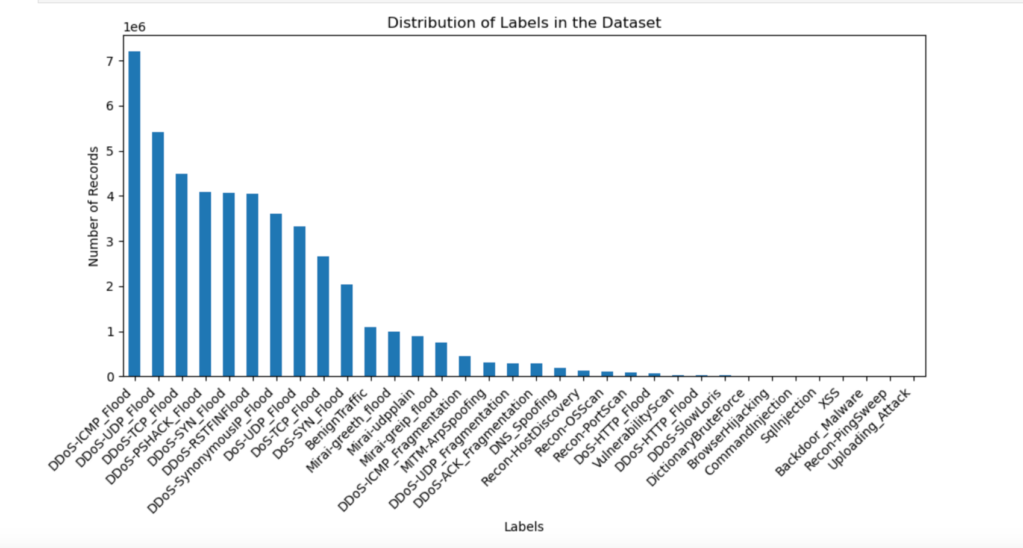

Figure 3.2 - Distributions of the types of attacks records.

Table 3.1- Percentage and count of various attack types within the CICIoT2023 dataset

|  |  |  |  |
| --- | --- | --- | --- |
|  | **Attack types** | **Number of Records** | **Percentage** |
| 1 | DDoS-ICMP_Flood | 7200504 | 15.42 |
| 2 | DDoS-UDP_Flood | 5412287 | 11.59 |
| 3 | DDoS-TCP_Flood | 4497667 | 9.63 |
| 4 | DDoS-PSHACK_Flood | 4094755 | 8.77 |
| 5 | DDoS-SYN_Flood | 4059190 | 8.69 |
| 6 | DDoS-RSTFINFlood | 4045285 | 8.66 |
| 7 | DDoS-SynonymousIP_Flood | 3598138 | 7.71 |
| 8 | DoS-UDP_Flood | 3318595 | 7.11 |
| 9 | DoS-TCP_Flood | 2671445 | 5.72 |
| 10 | DoS-SYN_Flood | 2028834 | 4.35 |
| 11 | BenignTraffic | 1098195 | 2.35 |
| 12 | Mirai-greeth_flood | 991866 | 2.12 |
| 13 | Mirai-udpplain | 890576 | 1.91 |
| 14 | Mirai-greip_flood | 751682 | 1.61 |
| 15 | DDoS-ICMP_Fragmentation | 452489 | 0.97 |
| 16 | MITM-ArpSpoofing | 307593 | 0.66 |
| 17 | DDoS-UDP_Fragmentation | 286925 | 0.61 |
| 18 | DDoS-ACK_Fragmentation | 285104 | 0.61 |
| 19 | DNS_Spoofing | 178911 | 0.38 |
| 20 | Recon-HostDiscovery | 134378 | 0.29 |
| 21 | Recon-OSScan | 98259 | 0.21 |
| 22 | Recon-PortScan | 82284 | 0.18 |
| 23 | DoS-HTTP_Flood | 71864 | 0.15 |
| 24 | VulnerabilityScan | 37382 | 0.08 |
| 25 | DDoS-HTTP_Flood | 28790 | 0.06 |
| 26 | DDoS-SlowLoris | 23426 | 0.05 |
| 27 | DictionaryBruteForce | 13064 | 0.03 |
| 28 | BrowserHijacking | 5859 | 0.01 |
| 29 | CommandInjection | 5409 | 0.01 |
| 30 | SqlInjection | 5245 | 0.01 |
| 31 | XSS | 3846 | 0.01 |
| 32 | Backdoor_Malware | 3218 | 0.01 |
| 33 | PingSweep | 2262 | 0.00 |
| 34 | Uploading_Attack | 1252 | 0.00 |
|  | **TOTAL** | **46,686,579** | **100.00** |

### Dataset

A dataset may be defined as a structured compilation of information that is organised in a systematic manner to serve a particular purpose. According to (Ozsahin et al., 2022), the utilisation of descriptive statistics improves the presentation of datasets, facilitating a clearer understanding. Table 3.2 which is adapted from (Neto et al., 2023), shows the features and descriptions of the CICIoT2023 dataset.

Table 3.2- CICIoT2023 Dataset Feature description

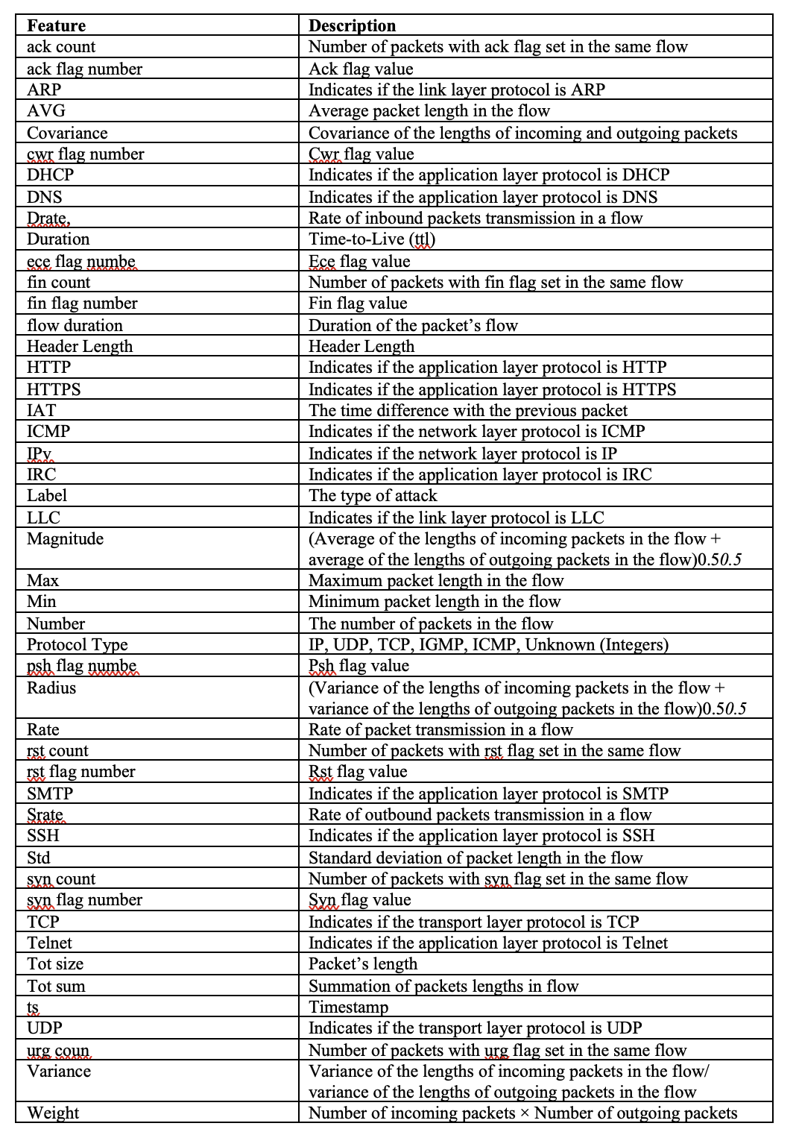

### Data Pre-processing

Data pre-processing stands as an indispensable phase in the development of an IDS employing ML methodologies. This pivotal procedure encompasses the refinement of raw data sourced from the CICIoT2023 dataset to facilitate effective learning by the hybrid ML model. The necessity for meticulous data pre-processing arises from the intricate nature of the dataset, which necessitates optimization to ensure the hybrid model's efficacy in discerning intrusion patterns accurately (Neto et al., 2023; *UNB CIC IOT 2023 Dataset*, 2023).

In the context of utilizing the CICIoT2023 dataset for IDS development, data pre-processing assumes paramount significance. This dataset, comprising CSV files encapsulating diverse attributes pertinent to network traffic, mandates preparatory measures for seamless integration into the training and testing phases of the ML models. The spectrum of pre-processing tasks encompasses data cleansing, treatment of missing values, feature curation, normalization, transformation, and partitioning to foster optimal performance of the hybrid ML model. Thus, data pre-processing emerges as a fundamental facet in harnessing the potential of machine learning for robust intrusion detection systems.

### Data Cleaning

The initial step in data pre-processing is data cleaning, which involves scrutinizing the dataset for any inaccuracies or inconsistencies that could affect the performance of the model. This step includes removing duplicate entries, correcting erroneous data points, and addressing outliers that may skew the results. Given the complexity of network data, it is crucial to ensure that the dataset is as accurate and representative of normal and malicious network traffic as possible.

The data cleaning process for the CICIoT2023 dataset will involve several key steps:

1. Duplicate Removal: The dataset will be scrutinized for duplicate records, which can skew the results and lead to overfitting. Duplicate entries will be identified and removed to maintain the uniqueness of each data point.
2. Error Correction: Any errors in data entry or processing will be corrected. This includes standardizing the formatting of data, such as ensuring consistent date formats and correcting typographical errors in categorical data.
3. Consistency Checks: The dataset will be checked for logical consistency. For example, ensuring that all IP addresses follow a valid format and that protocol types match the corresponding port numbers.
4. Handling Missing Values: As indicated in the statistical summary, some features may contain missing values. Appropriate strategies, such as imputation using the median or mode, will be employed to address these gaps without introducing bias.
5. Feature Verification: Each feature will be verified to ensure it aligns with the expected data type and range. For instance, numerical features should not contain non-numeric characters, and categorical features should have a defined set of possible values.

By meticulously cleaning the data, the hybrid ML model's ability to learn from the dataset and improve its accuracy in detecting intrusions will be enhanced. This step is crucial in building a reliable and robust IDS that can effectively safeguard IoT networks from a variety of cyber threats.

### Data Splitting for the Hybrid Model Training and Evaluation

After cleaning and pre-processing the data, the next step is to split the dataset into separate training and test sets. This split is typically done randomly and stratified by the target variable to maintain the distribution of classes in both sets. The training set is used to train the model, while the test set is used to evaluate its performance. The methodology for splitting the data in the context of the hybrid model would include:

1. Determining Split Ratios: Decide on the proportion of data to be used for training and testing. A common split ratio is 80% for training and 20% for testing, but this can vary based on the size and specifics of the dataset.
2. Stratification: Ensure that the split maintains the proportion of each class in both the training and test sets, which is especially important in datasets with imbalanced classes.
3. Randomization: Randomly shuffle the data before splitting to prevent any bias that may be introduced by the order of the data.
4. Consistency: Use a consistent random seed to ensure that the split is reproducible, which is important for the validation of the model's performance.
5. Validation Set: Optionally, a portion of the training set can be further split off to create a validation set, which can be used for tuning hyperparameters and making decisions about the model without using the test set.
6. Cross-Validation: Consider using cross-validation techniques, especially if the dataset is small or if a more robust estimate of the model's performance is desired.
7. Hybrid Model Training: Train the hybrid model on the training set, using the selected features and architecture designed for the Random Forest and Deep Neural Network components.
8. Model Evaluation: Evaluate the hybrid model on the test set to assess its performance and compare it with baseline models or previous iterations.

By following these steps, you can ensure that the hybrid model is evaluated fairly and that its performance metrics reflect its ability to generalize to new, unseen data.

### Training and Validation

1. Training Data Utilization: The hybrid model's training phase will leverage the CICIoT2023 dataset, which encompasses a wide array of network traffic, including benign and various attack types such as DDoS, DoS, and Reconnaissance amongst others. The model will be trained using the features (e.g., flow duration, protocol type) alongside their corresponding labels (e.g., attack type). The hybrid model is constructed by training different ensemble models and DNN models separately on the training dataset. Optionally, hyperparameters for both models can be fine-tuned using techniques such as grid search or random search. After training, both models are saved for future use.
2. Validation Approach: To ensure the model's generalization, a validation strategy will be implemented during the training phase. Techniques like k-fold cross-validation will be used to assess the model's performance on different data segments, aiding in hyperparameter tuning and mitigating overfitting risks.

### Testing and Evaluation

1. Testing Dataset Application: Post-training, the hybrid model's efficacy will be gauged using a distinct dataset segment designated for testing. This step is crucial for an impartial evaluation of the model's predictive capabilities on data that simulates real-world IDS encounters.
2. Performance Metrics Selection: The model's performance will be quantified using metrics such as accuracy, precision, recall, F1-score, ROC-AUC, and confusion matrices. These metrics are instrumental in determining the model's proficiency in accurately classifying network traffic types.

### Comparative Analysis

1. Baseline Model Benchmarking: The hybrid model's performance will be benchmarked against standard models like Random Forest, standalone DNNs, and conventional rule-based IDS methods. This comparison is vital for evaluating the hybrid model's relative effectiveness.
2. Performance Trade-off Assessment: It is essential to weigh the hybrid model against other models in terms of performance metrics, complexity, training duration, and resource demands. The hybrid approach may offer benefits such as heightened detection rates and fewer false positives.
3. Real-World Deployment Considerations: The practical deployment of the hybrid model will be scrutinized, considering factors like scalability, interpretability, and maintenance ease to ascertain the model's deployment feasibility in real-world settings.

## Research Method

The research will employ a mixed-methods approach, combining quantitative analysis of IoT security data with qualitative insights from cybersecurity experts. This approach allows for a comprehensive understanding of the effectiveness of machine learning techniques in detecting and mitigating threats within IoT networks. The primary data source will be the CICIoT2023 dataset, which includes a wide range of IoT attack scenarios and benign data, providing a robust foundation for training and testing machine learning models

## Research Design

The study is designed to systematically evaluate the performance of various machine learning models, including different ensemble models and Deep Neural Networks (DNN), in identifying and classifying potential threats in IoT networks. The research will involve the following stages:

1. Data Pre-processing: Cleaning and preparing the CICIoT2023 dataset for analysis, including feature selection and normalization.
2. Model Training: Training the selected ensemble and DNN models on a subset of the pre-processed dataset.
3. Model Evaluation: Testing the trained models on a separate subset of the dataset to assess their accuracy, precision, recall, and F1-score in detecting IoT threats.
4. Comparative Analysis: Comparing the performance of the different ensemble and DNN models against traditional intrusion detection systems (IDS) to determine their relative effectiveness.

## Data Analysis Plan

Data analysis will involve both descriptive and inferential statistics to evaluate the performance of machine learning models. Key performance indicators (KPIs) such as accuracy, precision, recall, and F1-score will be calculated for each model. Additionally, confusion matrices will be used to visualize the models' performance in correctly identifying different types of attacks within the IoT network.

## Machine Learning

### Introduction

ML offers a dynamic approach to enhancing IoT security by enabling systems to learn from data, identify patterns, and make decisions with minimal human intervention. This section introduces the ML models that will be used in this research in detecting and mitigating threats in IoT networks.

### Ensemble Methods in Machine Learning

Ensemble methods are a class of machine learning algorithms that combine multiple models to improve the overall predictive performance (Dietterich, 2000).These methods construct a set of classifiers and then classify new data points by taking a weighted vote of their predictions (Dietterich, 2000). Some of the popular ensemble methods include Bayesian averaging, error-correcting output coding, Bagging, and Boosting (Dietterich, 2000).

Ensemble methods have been shown to often perform better than any single classifier, as they can leverage the strengths of different models and compensate for their individual weaknesses. This is particularly useful when dealing with high-dimensional, complex regression and classification problems (Kazienko et al., 2013; Nilashi et al., 2022; Sahithi et al., 2022)

### Random Forest (RF)

RF algorithm is a sophisticated ensemble learning technique utilised for many applications such as classification and regression. During the training process, the system generates several decision trees and subsequently determines the class that represents the mode of the classes (classification) or the mean prediction (regression) of each individual tree. Random Forest (RF) addresses the issue of decision trees overfitting to their training set (Breiman, 2001; Tyralis et al., 2019; Wang et al., 2023).

RF algorithm was initially introduced by Tin Kam Ho in 1995, employing the random subspace technique. Leo Breiman and Adele Cutler devised an algorithm extension, which they subsequently filed as a trademark under the name "Random Forests." The proposed expansion integrates Breiman's concept of "bagging" with the random selection of features in order to create a set of decision trees that exhibit controlled variation (Breiman, 2001).

RF models are renowned for their capacity to effectively process extensive data sets characterised by increasing dimensionality. The ability to uphold correctness persists even in cases when a significant piece of the data is absent, and they possess the capability to make estimations for the missing data. RF possesses a notable advantage in its feature selection technique, which enables it to accurately identify the most relevant variables within the dataset.

### Ensemble Voting Method

The Ensemble Voting Method combines the predictions of multiple base classifiers using a voting scheme, such as majority voting or weighted voting. This allows the ensemble to leverage the strengths of different models and improve the overall predictive performance (Dietterich, 2000)

### Random Subspace Method

The Random Subspace Method is an ensemble technique that trains multiple base classifiers on random subsets of the feature space. This can help to reduce the correlation between the base classifiers and improve the ensemble's ability to capture complex patterns in the data (Dietterich, 2000).

### Bayesian Model Averaging

Bayesian Model Averaging is a technique that combines multiple models by weighting them according to their posterior probabilities. This can help to account for model uncertainty and improve the robustness of the predictions.

Overall, ensemble methods have been widely used in various machine learning applications, such as credit card fraud detection (Sahithi et al., 2022) and Parkinson's disease progression prediction (Nilashi et al., 2022) due to their ability to improve the predictive performance and robustness of the models.

### Deep Neural Network (DNN)

DNNs are a classification of machine learning algorithms specifically developed to represent intricate non-linear connections. DNNs are distinguished by their profound architecture, comprising several layers positioned between the input and output layers. The layers include of nodes or neurons that carry out sequential processing of the incoming data, enabling the network to acquire high-level characteristics from the data with little human involvement (Öner and Sin, 2021).

DNNs have demonstrated notable efficacy in managing extensive quantities of unstructured data, encompassing pictures, sound, and text. Successful applications of these technologies have been observed across several areas, encompassing picture and audio recognition, natural language processing, and autonomous driving. DNNs has the capacity to acquire knowledge directly from unprocessed input, autonomously uncovering the necessary representations for tasks involving detection or classification (Öner and Sin, 2021).

The standard structure of a deep neural network (DNN) comprises an input layer, many hidden layers, and an output layer. Each layer is comprised of several neurons that are interconnected with neurons in both the preceding and succeeding layers. The capacity of a network to effectively represent intricate interactions is significantly influenced by its depth, denoting the quantity of hidden layers it possesses. Nevertheless, the training process of deep neural networks (DNNs) is computationally demanding due to its depth, necessitating a significant volume of data in order to attain optimal performance.  
ANNs have significantly transformed the domain of machine learning by facilitating the attainment of unparalleled levels of accuracy in tasks that were previously deemed difficult for computational systems. The capacity to acquire hierarchical representations of data renders them a potent instrument for identifying patterns and generating predictions from datasets with a high number of dimensions.

## Ethical Concern

The research will adhere to ethical guidelines, ensuring the privacy and security of data used in the study. All data analysis will be conducted in a manner that respects the confidentiality of the information contained within the dataset. Additionally, the study will consider the ethical implications of deploying machine learning-based security solutions in real-world IoT networks.

This comprehensive approach to researching the application of machine learning in securing IoT networks aims to provide valuable insights into the effectiveness of RF and DNN models in detecting and mitigating advanced cyber threats.

# Chapter 4 – Implementation and Results

## 4.1. Introduction

This chapter presents the implementation of a hybrid ML model and the results derived from its application to the CICIoT2023 dataset. The enhanced hybrid model incorporates a suite of ensemble methods, including Random Forest (RF), Deep Neural Networks (DNN), Ensemble Voting, Random Subspace Method, and Bayesian Model Averaging, to evaluate and determine the most effective technique for classifying large-scale attacks in IoT environments. This approach builds upon the foundational work reported by Neto et al. (2023), which demonstrated the efficacy of RF and DNN in identifying and classifying cyber threats. The chapter is meticulously structured to provide an exhaustive account of the data pre-processing steps, the refined implementation strategy for the hybrid model, and a comprehensive evaluation of its performance against a wide spectrum of attack scenarios and benign data within the CICIoT2023 dataset.

The chapter aims to establish a new benchmark for IoT security by deploying a hybrid ML model that harnesses the collective strengths of multiple ensemble methods. By leveraging the comprehensive CICIoT2023 dataset and insights gained from the preliminary ML evaluation, the proposed solution seeks to proactively identify and mitigate a wide array of cyber threats, thereby significantly improving the security of IoT networks.

The data pre-processing phase is essential in preparing the CICIoT2023 dataset for thorough analysis and modeling. The following sections will elaborate on the data cleaning and transformation processes, the integration of various ensemble methods into the hybrid model, the strategic implementation, and the rigorous evaluation and optimization of the model's performance. The chapter will conclude with a summary of the findings, emphasizing the enhanced effectiveness of the ML models in fortifying IoT network security through advanced threat detection.

## 4.2. Proposed Solution

The proposed solution for enhancing the security of IoT networks involves the development and implementation of a hybrid ML model. This model integrates a diverse array of powerful classification methods: RF, DNN, and additional ensemble techniques such as Ensemble Voting, Random Subspace Method, and Bayesian Model Averaging. This approach is informed by the preliminary results of ML evaluation conducted by (Neto et al., 2023). The study highlighted the effectiveness of these ML techniques in identifying and classifying large-scale attacks in IoT environments, providing a solid foundation for the proposed solution.

### 4.2.1. Integration of RF and DNN

The hybrid model capitalizes on the unique strengths of RF, DNN, and other ensemble methods to establish a robust Intrusion Detection System (IDS) capable of accurately detecting a vast array of cyber threats targeting IoT networks. The integration of these methods involves:

* RF is an ensemble learning method known for its high accuracy, ability to handle large datasets with higher dimensionality, and its feature selection capabilities. It operates by constructing multiple decision trees during the training phase and outputting the class that is the mode of the classes (classification) or mean prediction (regression) of the individual trees. RF's ability to assess the importance of features makes it particularly effective in identifying relevant indicators of malicious activity within the IoT network traffic.
* DNNs are characterized by their deep architecture, consisting of multiple layers between the input and output layers. These networks excel at learning complex, non-linear relationships in the data, making them highly effective at feature learning and classification tasks. DNNs can autonomously extract high-level features from raw data, enhancing the model's ability to detect subtle patterns indicative of cyber threats.
* Ensemble Voting Method combines the predictions from the Naive Bayes and Logistic Regression models, along with other classifiers, to make a final decision based on majority voting or weighted averages.
* Random Subspace Method trains each model on a random subset of features, which helps in improving diversity among the models and potentially increases overall accuracy.
* Bayesian Model Averaging uses probabilistic models such as RF and DNN, averaging their predictions based on Bayesian inference to improve classification performance.

### 4.2.2. Implementation Strategy

The implementation of the hybrid model follows a strategic approach where each ensemble method is trained using the CICIoT2023 dataset. The most relevant features are identified and selected, and complex patterns are learned to classify network traffic effectively. The synergy of RF's feature selection, DNN's pattern recognition, and the robustness of other ensemble methods ensures a comprehensive analysis of IoT network traffic, leading to precise and efficient threat detection

### 4.2.3. Evaluation and Optimization

The performance of the hybrid model will be rigorously evaluated using the CICIoT2023 dataset, which includes a diverse range of attack scenarios and benign data. Key performance metrics such as accuracy, precision, recall, and F1-score will be used to assess the model's effectiveness in detecting various types of attacks. Additionally, the model will be optimized through hyperparameter tuning and cross-validation techniques to enhance its generalization ability and reduce the risk of overfitting.

The proposed solution is designed to significantly advance the security of IoT networks by deploying a hybrid ML model that unites the strengths of RF, DNN, and other ensemble methods. By leveraging the comprehensive CICIoT2023 dataset and insights from the preliminary ML evaluation, the solution aims to set a new benchmark for IoT security, capable of proactively identifying and neutralizing a wide spectrum of cyber threats.

## 4.3. Data Pre-processing

Data pre-processing is a crucial phase in the development of an IDS using hybrid ML techniques. This phase involves preparing the CICIoT2023 dataset for analysis and modelling, ensuring that the data is clean, relevant, and structured in a way that enhances the performance of the machine learning models. The pre-processing steps undertaken are pivotal in optimizing the dataset for effective learning and accurate intrusion pattern recognition.

### 4.3.1. Data Cleaning

Data cleaning is the foundational step in the data pre-processing stage, focusing on enhancing the dataset's quality by addressing inaccuracies, inconsistencies, or missing values that could potentially skew the analysis. This process is vital for ensuring the integrity and reliability of the ML models developed for IDS.

* Duplicate Removal and Error Correction: The initial actions involve identifying and removing duplicate records and correcting any errors present in the dataset. This step is crucial for maintaining the uniqueness of each data point and ensuring the accuracy of the information.
* Consistency Checks and Handling Missing Values: The dataset undergoes thorough consistency checks to ensure logical coherence, such as verifying the format of IP addresses and matching protocol types with corresponding port numbers. Additionally, strategies for handling missing values are employed, such as imputation, to address gaps without introducing bias.
* Feature Verification: Each feature within the dataset is verified to confirm its alignment with the expected data type and range. This verification process ensures that numerical features are free from non-numeric characters and that categorical features adhere to a defined set of possible values.

The meticulous data cleaning process lays a solid foundation for the subsequent pre-processing steps, enhancing the machine learning model's ability to learn from the dataset and accurately detect intrusions.

The data cleaning process, as illustrated in Figure 4.1, conclusively verified the absence of missing values within the extensive CICIoT2023 dataset. Given the dataset's substantial size, exceeding 46 million records, a chunk-based processing approach was employed. This strategy enabled efficient handling of the dataset's voluminous data while ensuring computational feasibility.

The comprehensive nature of the dataset suggests its suitability for training ML models, encompassing a diverse range of data attributes conducive to model development. The outcome underscores the dataset's robust completeness and underscores its readiness for advanced analysis and modelling endeavours.

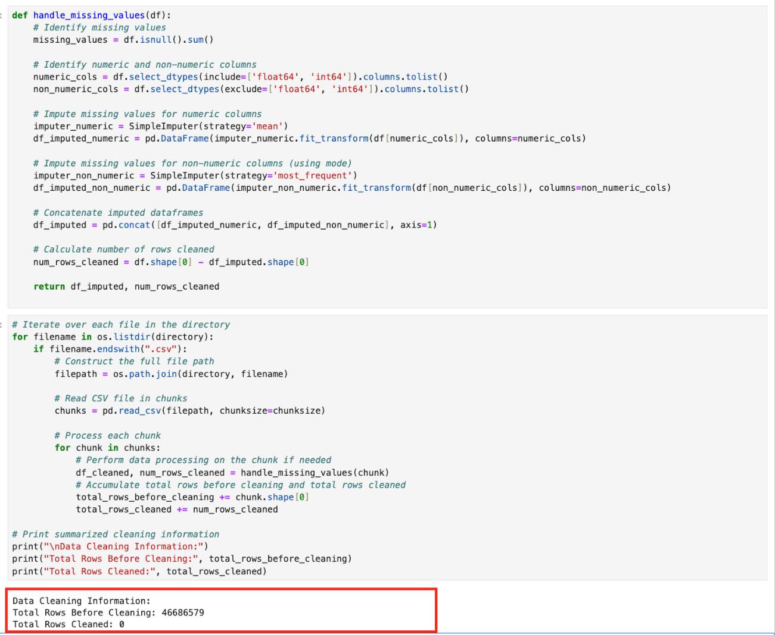

Figure 4.1 Data cleaning process and results.

### 4.3.2. Data Transformation

Following data cleaning, the next critical step in data pre-processing is data transformation. This stage involves converting the cleaned data into a format that is more suitable for analysis by the machine learning models. The transformation process includes encoding categorical variables, normalizing numerical features, and integrating various data sources into a cohesive dataset.

* Categorical Variables Encoding: Categorical variables within the dataset, such as protocol types or attack categories, are encoded into numerical representations. This encoding is essential for compatibility with machine learning algorithms, which typically require numerical input. Techniques such as one-hot encoding and label encoding are employed based on the nature of the categorical variables.
* Normalization of Numerical Features: Numerical features are normalized to ensure that they are on a similar scale. This normalization is crucial for models that are sensitive to the scale of input features, as it prevents features with larger values from dominating those with smaller values.
* Integration of Encoded Features: The encoded categorical variables and normalized numerical features are then integrated into a single dataset. This integration process creates a comprehensive dataset that combines the information from various features, enhancing the representational capacity of the dataset for machine learning analysis.

The data transformation process is instrumental in preparing the CICIoT2023 dataset for effective utilization in ML models. By encoding categorical variables and normalizing numerical features, the dataset is transformed into a format that is conducive to the development of accurate and robust ML models for intrusion detection in IoT environments.

The data transformation process as illustrated in figure 4.2 successfully prepared the CICIoT2023 dataset for ML analysis by incorporating both numerical and encoded categorical features. This enhances the dataset's utility for developing accurate and robust machine learning models for intrusion detection in IoT environments.

The transformation process did not require any rows to be transformed, indicating that the dataset was either pre-processed or did not contain categorical variables needing encoding.

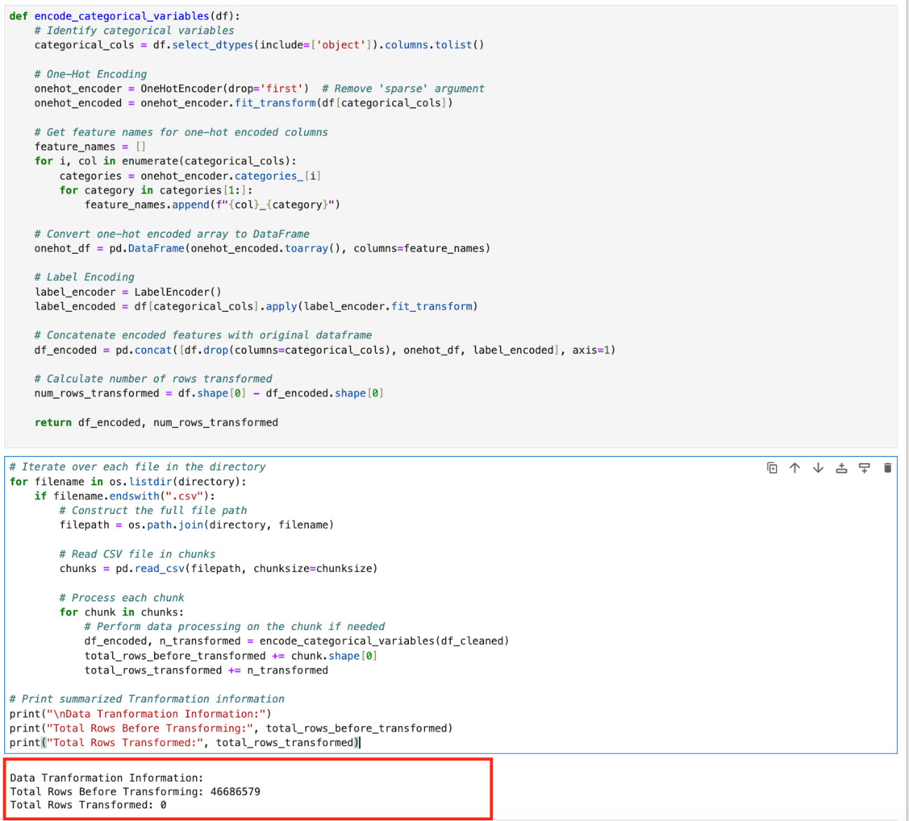

Figure 4.2 Data transformation and output

### 4.3.3. Subset Selection and Model Training

To address the computational limitations of the host machine in training and evaluating the models using the full CICIoT2023 dataset, a subset of the dataset was selected for analysis. The subset was chosen to contain 20% of the total records, ensuring that the dataset remains representative of the original data while being computationally feasible for the host machine.

The subset selection process involved random sampling to ensure that the selected records were representative of the entire dataset. This approach ensured that the model's performance on the subset was indicative of its performance on the full dataset.

The selected subset was then used to train and evaluate the models using the same evaluation metrics as for the full dataset. This approach allowed for the efficient training and evaluation of the models while maintaining the dataset's integrity.

In conclusion, the subset selection and model training approach allowed for the efficient training and evaluation of the models while still maintaining the integrity of the dataset. This approach can be useful in situations where computational resources are limited, and the full dataset is too large to be processed.

## 4.4. Result Analysis and Evaluation

The result analysis and evaluation section present the results of all the model evaluations, including RF, DNN, and other ensemble methods. The evaluation process was rigorous and comprehensive, utilizing the CICIoT2023 dataset, which includes a diverse range of attack scenarios and benign data. Key performance metrics such as accuracy, precision, recall, and F1-score were used to assess the model's effectiveness in detecting various types of attacks.

### 4.4.1 Model Performance Metrics

The performance of the models was evaluated using the following metrics:

* Accuracy: The proportion of correct predictions made by the model.
* Precision: The ratio of true positives (TP) to the total number of positive predictions (TP + FP).
* Recall: The ratio of true positives (TP) to the total number of actual positive instances (TP + FN).
* F1-score: The harmonic means of precision and recall, providing a balanced measure of model performance.

### 4.4.2. Random Forest

The Random Forest model demonstrates robust performance across various classes, achieving high precision and recall scores for many categories. It particularly excels in distinguishing benign traffic, DDoS attacks, and some forms of malware. This model's strength lies in its ability to handle many features and maintain accuracy without overfitting. However, it struggles with classes that have imbalanced data or complex patterns, resulting in lower precision and recall scores for certain types of attacks such as backdoor malware and browser hijacking. Table 4.1 presents the result of the model evaluation and Figure 4.3 present the confusion matrix for the RF classifier.

Table 4.1 Random Forest Evaluation result

|  |  |  |  |
| --- | --- | --- | --- |
| **Class** | precision | recall | f1-score |
| Backdoor_Malware | 0.86 | 0.14 | 0.24 |
| BenignTraffic | 0.89 | 0.99 | 0.94 |
| BrowserHijacking | 0.89 | 0.26 | 0.4 |
| CommandInjection | 0.81 | 0.28 | 0.42 |
| DDoS-ACK_Fragmentation | 1 | 0.99 | 0.99 |
| DDoS-HTTP_Flood | 0.99 | 0.98 | 0.98 |
| DDoS-ICMP_Flood | 1 | 1 | 1 |
| DDoS-ICMP_Fragmentation | 0.99 | 1 | 1 |
| DDoS-PSHACK_Flood | 1 | 1 | 1 |
| DDoS-RSTFINFlood | 1 | 1 | 1 |
| DDoS-SYN_Flood | 1 | 1 | 1 |
| DDoS-SlowLoris | 0.92 | 0.99 | 0.96 |
| DDoS-SynonymousIP_Flood | 1 | 1 | 1 |
| DDoS-TCP_Flood | 1 | 1 | 1 |
| DDoS-UDP_Flood | 1 | 1 | 1 |
| DDoS-UDP_Fragmentation | 1 | 0.99 | 1 |
| DNS_Spoofing | 0.83 | 0.75 | 0.79 |
| DictionaryBruteForce | 0.97 | 0.44 | 0.6 |
| DoS-HTTP_Flood | 0.99 | 1 | 1 |
| DoS-SYN_Flood | 1 | 1 | 1 |
| DoS-TCP_Flood | 1 | 1 | 1 |
| DoS-UDP_Flood | 1 | 1 | 1 |
| MITM-ArpSpoofing | 0.91 | 0.85 | 0.88 |
| Mirai-greeth_flood | 1 | 1 | 1 |
| Mirai-greip_flood | 1 | 1 | 1 |
| Mirai-udpplain | 1 | 1 | 1 |
| Recon-HostDiscovery | 0.87 | 0.86 | 0.87 |
| Recon-OSScan | 0.84 | 0.6 | 0.7 |
| Recon-PingSweep | 0.5 | 0.03 | 0.6 |
| Recon-PortScan | 0.83 | 0.64 | 0.72 |
| SqlInjection | 0.92 | 0.21 | 0.35 |
| Uploading_Attack | 0.5 | 0.02 | 0.04 |
| VulnerabilityScan | 0.96 | 0.99 | 0.98 |
| XSS | 0.58 | 0.14 | 0.22 |
| **Accuracy** | **0.9947** | | |

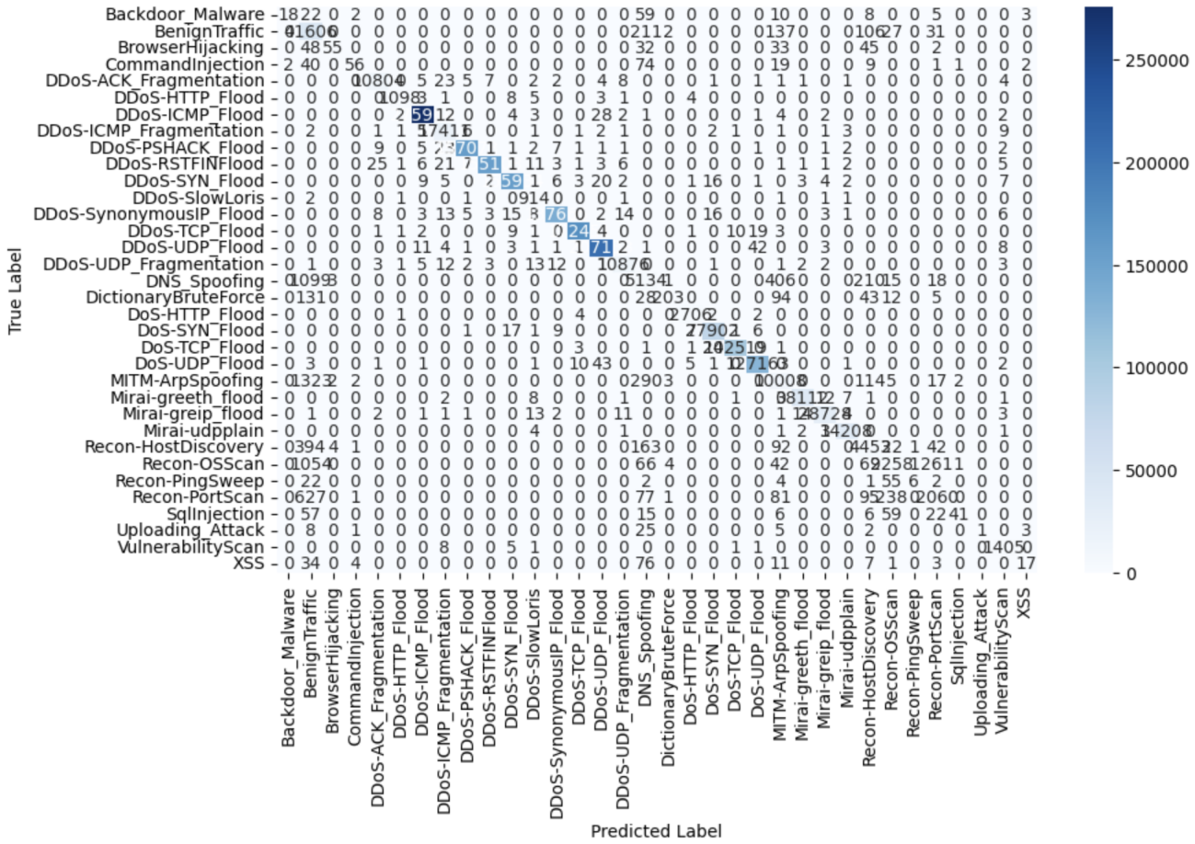

Figure 4.3 - Random Forest classifier’s confusion matrix

### 4.4.3. Deep Neural Network

The DNN exhibits mixed performances across different classes. While it achieves commendable precision and recall for benign traffic, it struggles with accurately identifying various attack types, resulting in lower overall accuracy compared to other models. The DNN's effectiveness heavily relies on the complexity of the data and the architecture of the neural network. Despite its potential for learning intricate patterns, it requires careful tuning and extensive training data to perform well across all classes. Table 4.2 presents the result of the model’s evaluation and Figure 4.4 present the confusion matrix of the DNN classifier.

Table 4.2 DNN evaluation result

|  |  |  |  |
| --- | --- | --- | --- |
| **Class** | precision | recall | f1-score |
| Backdoor_Malware | 0 | 0 | 0 |
| BenignTraffic | 0.72 | 0.95 | 0.82 |
| BrowserHijacking | 0 | 0 | 0 |
| CommandInjection | 0 | 0 | 0 |
| DDoS-ACK_Fragmentation | 0.99 | 0.98 | 0.99 |
| DDoS-HTTP_Flood | 0.91 | 0.57 | 0.7 |
| DDoS-ICMP_Flood | 1 | 1 | 1 |
| DDoS-ICMP_Fragmentation | 1 | 0.97 | 0.99 |
| DDoS-PSHACK_Flood | 1 | 1 | 1 |
| DDoS-RSTFINFlood | 1 | 1 | 1 |
| DDoS-SYN_Flood | 1 | 1 | 1 |
| DDoS-SlowLoris | 0.55 | 0.46 | 0.5 |
| DDoS-SynonymousIP_Flood | 1 | 1 | 1 |
| DDoS-TCP_Flood | 1 | 1 | 1 |
| DDoS-UDP_Flood | 1 | 1 | 1 |
| DDoS-UDP_Fragmentation | 1 | 0.94 | 0.97 |
| DNS_Spoofing | 0.6 | 0.08 | 0.15 |
| DictionaryBruteForce | 0 | 0 | 0 |
| DoS-HTTP_Flood | 0.91 | 0.9 | 0.9 |
| DoS-SYN_Flood | 0.99 | 0.99 | 0.99 |
| DoS-TCP_Flood | 1 | 0.99 | 0.99 |
| DoS-UDP_Flood | 0.99 | 1 | 0.99 |
| MITM-ArpSpoofing | 0.78 | 0.51 | 0.61 |
| Mirai-greeth_flood | 0.99 | 0.97 | 0.98 |
| Mirai-greip_flood | 0.96 | 0.97 | 0.97 |
| Mirai-udpplain | 1 | 0.99 | 0.99 |
| Recon-HostDiscovery | 0.41 | 0.53 | 0.46 |
| Recon-OSScan | 0.33 | 0 | 0 |
| Recon-PingSweep | 0 | 0 | 0 |
| Recon-PortScan | 0.42 | 0.09 | 0.15 |
| SqlInjection | 0 | 0 | 0 |
| Uploading_Attack | 0 | 0 | 0 |
| VulnerabilityScan | 0.18 | 0.98 | 0.31 |
| XSS | 0 | 0 | 0 |
| **Accuracy** | **0.965** | | |

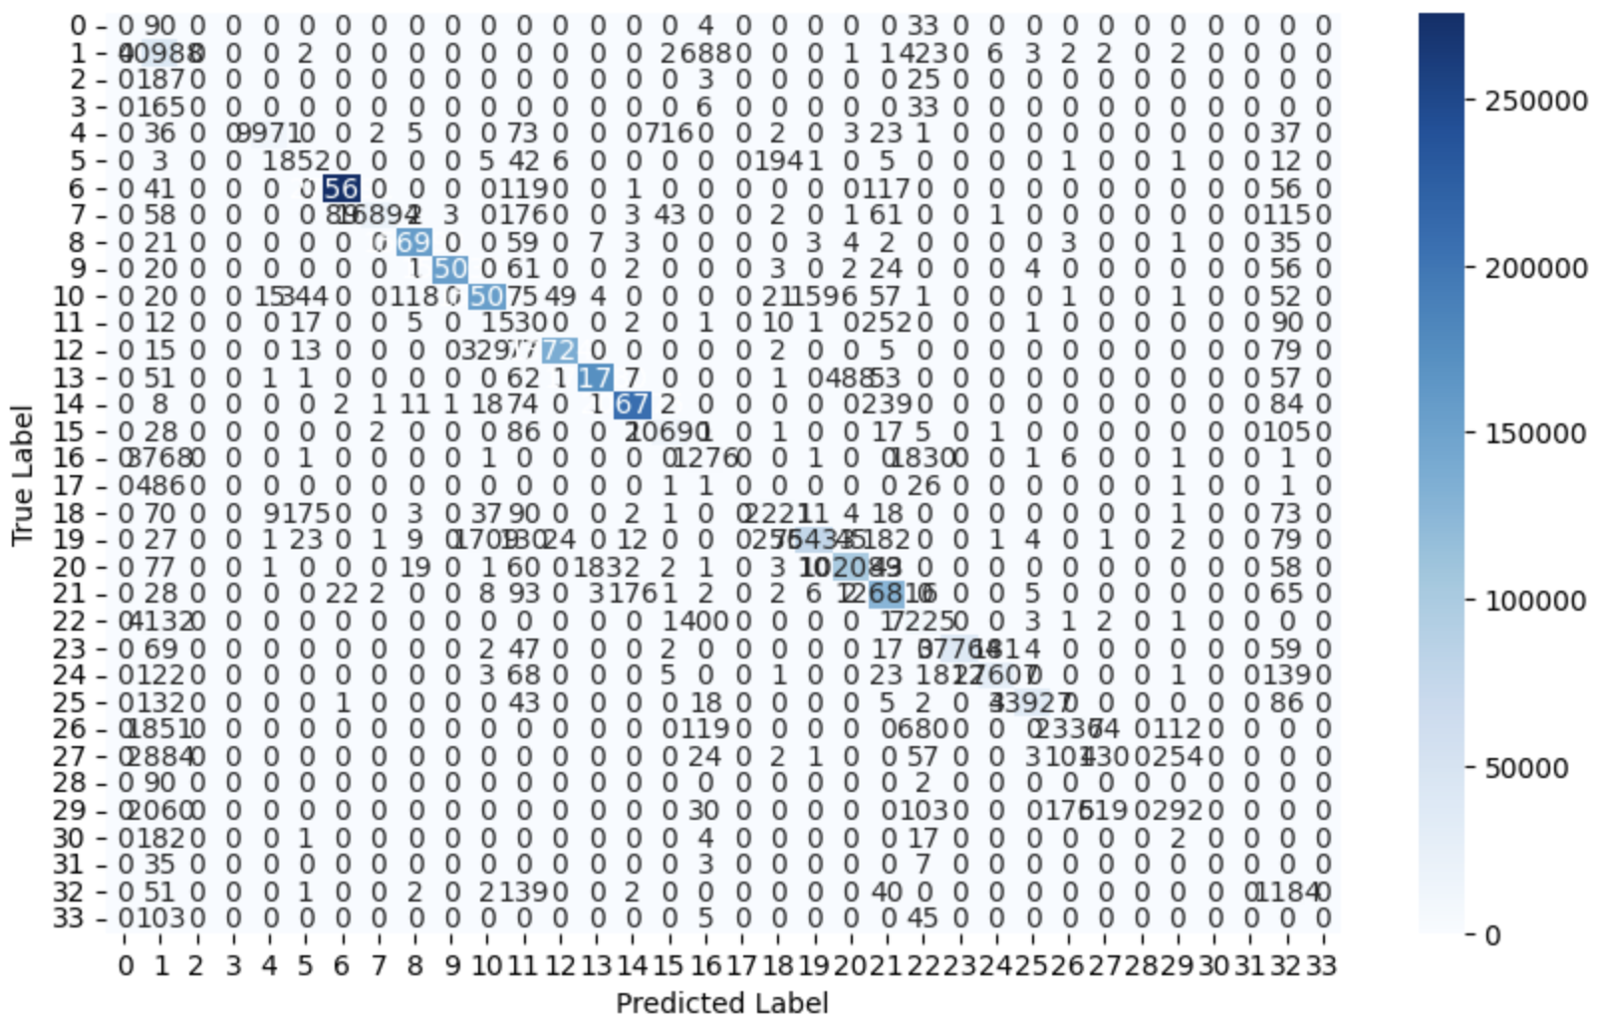

Figure 4.4 - Confusion matrix of DNN classifier

### 4.4.4. Ensemble Voting Method

The Ensemble Voting Method combines the strengths of Naive Bayes and Logistic Regression models through a voting mechanism. However, this ensemble method performs poorly compared to others, likely due to the simplistic nature of the base models. Naive Bayes assumes independence among features, which may not hold true in complex datasets like intrusion detection. Similarly, Logistic Regression's linear decision boundary might struggle to capture nonlinear relationships present in the data. As a result, this ensemble method exhibits limited effectiveness in accurately classifying different attack types. Table 4.3 presents the result of the model’s evaluation and Figure 4.5 present the confusion matrix of the classifier.

Table 4.3 Ensemble Voting Method Evaluation result

|  |  |  |  |
| --- | --- | --- | --- |
| **Class** | precision | recall | f1-score |
| Backdoor_Malware | 0 | 0.32 | 0 |
| BenignTraffic | 0.65 | 0.09 | 0.15 |
| BrowserHijacking | 0.01 | 0.06 | 0.01 |
| CommandInjection | 0 | 0.21 | 0 |
| DDoS-ACK_Fragmentation | 0.01 | 0.06 | 0.01 |
| DDoS-HTTP_Flood | 1 | 0.79 | 0.88 |
| DDoS-ICMP_Flood | 0.49 | 0.58 | 0.53 |
| DDoS-ICMP_Fragmentation | 1 | 1 | 1 |
| DDoS-PSHACK_Flood | 0.99 | 0.97 | 0.98 |
| DDoS-RSTFINFlood | 1 | 0.98 | 0.99 |
| DDoS-SYN_Flood | 1 | 1 | 1 |
| DDoS-SlowLoris | 0.61 | 0.1 | 0.18 |
| DDoS-SynonymousIP_Flood | 0.34 | 0.52 | 0.41 |
| DDoS-TCP_Flood | 0.41 | 0.99 | 0.58 |
| DDoS-UDP_Flood | 0.98 | 0.02 | 0.04 |
| DDoS-UDP_Fragmentation | 0.23 | 0 | 0 |
| DNS_Spoofing | 0.14 | 0 | 0 |
| DictionaryBruteForce | 0.48 | 0.18 | 0.26 |
| DoS-HTTP_Flood | 0.18 | 0.84 | 0.29 |
| DoS-SYN_Flood | 0.8 | 0.11 | 0.19 |
| DoS-TCP_Flood | 0.37 | 0.99 | 0.54 |
| DoS-UDP_Flood | 0.38 | 0.99 | 0.55 |
| MITM-ArpSpoofing | 0.91 | 0.13 | 0.23 |
| Mirai-greeth_flood | 0.58 | 0.99 | 0.73 |
| Mirai-greip_flood | 0.66 | 0.02 | 0.03 |
| Mirai-udpplain | 1 | 0.98 | 0.99 |
| Recon-HostDiscovery | 0.92 | 0.94 | 0.24 |
| Recon-OSScan | 0.05 | 0.02 | 0.04 |
| Recon-PingSweep | 0.2 | 0.18 | 0.19 |
| Recon-PortScan | 0.03 | 0.08 | 0.04 |
| SqlInjection | 0.18 | 0 | 0.01 |
| Uploading_Attack | 0.01 | 0.11 | 0.01 |
| VulnerabilityScan | 0 | 0.91 | 0 |
| XSS | 0.01 | 0.04 | 0.01 |
| **Accuracy** | **0.6101** | | |

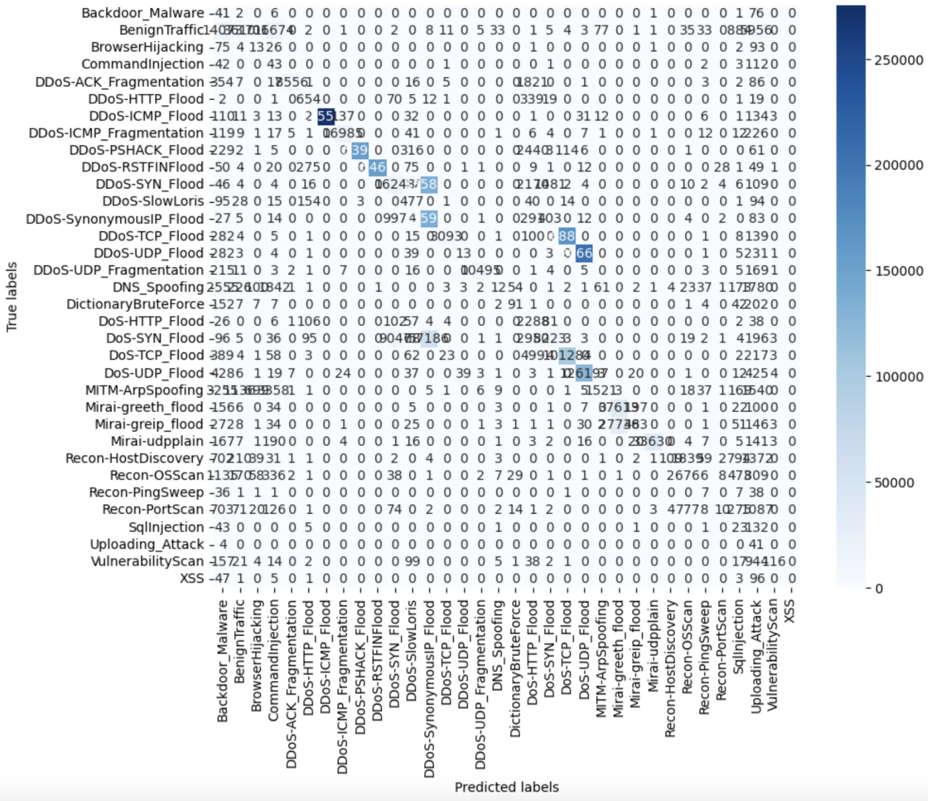

Figure 4.5 - Voting method classifier confusion matrix

### 4.4.5. Ensemble Random Subspace Method

The Ensemble Random Subspace Method demonstrates high accuracy and robustness by training multiple models on random subsets of features. This approach helps mitigate overfitting and captures diverse patterns present in the data. As a result, it achieves balanced precision and recall scores across various classes, making it suitable for general-purpose intrusion detection. The model's ability to maintain high performance in the presence of noise and imbalanced data enhances its suitability for real-world applications. Table 4.4 presents the result of the model’s evaluation and Figure 4.6 present the confusion matrix of the classifier.

Table 4.4 Ensemble Random Subspace Method Evaluation result

|  |  |  |  |
| --- | --- | --- | --- |
| **Class** | precision | recall | f1-score |
| Backdoor_Malware | 1 | 0.53 | 0.69 |
| BenignTraffic | 0.89 | 0.99 | 0.94 |
| BrowserHijacking | 0.97 | 0.59 | 0.73 |
| CommandInjection | 0.97 | 0.56 | 0.71 |
| DDoS-ACK_Fragmentation | 1 | 1 | 1 |
| DDoS-HTTP_Flood | 1 | 1 | 1 |
| DDoS-ICMP_Flood | 1 | 1 | 1 |
| DDoS-ICMP_Fragmentation | 1 | 1 | 1 |
| DDoS-PSHACK_Flood | 1 | 1 | 1 |
| DDoS-RSTFINFlood | 1 | 1 | 1 |
| DDoS-SYN_Flood | 1 | 1 | 1 |
| DDoS-SlowLoris | 1 | 1 | 1 |
| DDoS-SynonymousIP_Flood | 1 | 1 | 1 |
| DDoS-TCP_Flood | 1 | 1 | 1 |
| DDoS-UDP_Flood | 1 | 1 | 1 |
| DDoS-UDP_Fragmentation | 1 | 1 | 1 |
| DNS_Spoofing | 0.87 | 0.75 | 0.8 |
| DictionaryBruteForce | 0.98 | 0.57 | 0.72 |
| DoS-HTTP_Flood | 1 | 1 | 1 |
| DoS-SYN_Flood | 1 | 1 | 1 |
| DoS-TCP_Flood | 1 | 1 | 1 |
| DoS-UDP_Flood | 1 | 1 | 1 |
| MITM-ArpSpoofing | 0.94 | 0.85 | 0.89 |
| Mirai-greeth_flood | 1 | 1 | 1 |
| Mirai-greip_flood | 1 | 1 | 1 |
| Mirai-udpplain | 1 | 1 | 1 |
| Recon-HostDiscovery | 0.89 | 0.87 | 0.88 |
| Recon-OSScan | 0.9 | 0.61 | 0.73 |
| Recon-PingSweep | 1 | 0.59 | 0.74 |
| Recon-PortScan | 0.87 | 0.65 | 0.74 |
| SqlInjection | 0.98 | 0.55 | 0.75 |
| Uploading_Attack | 1 | 0.6 | 0.75 |
| VulnerabilityScan | 1 | 1 | 1 |
| XSS | 1 | 0.49 | 0.66 |
| **Accuracy** | **0.9955** | | |

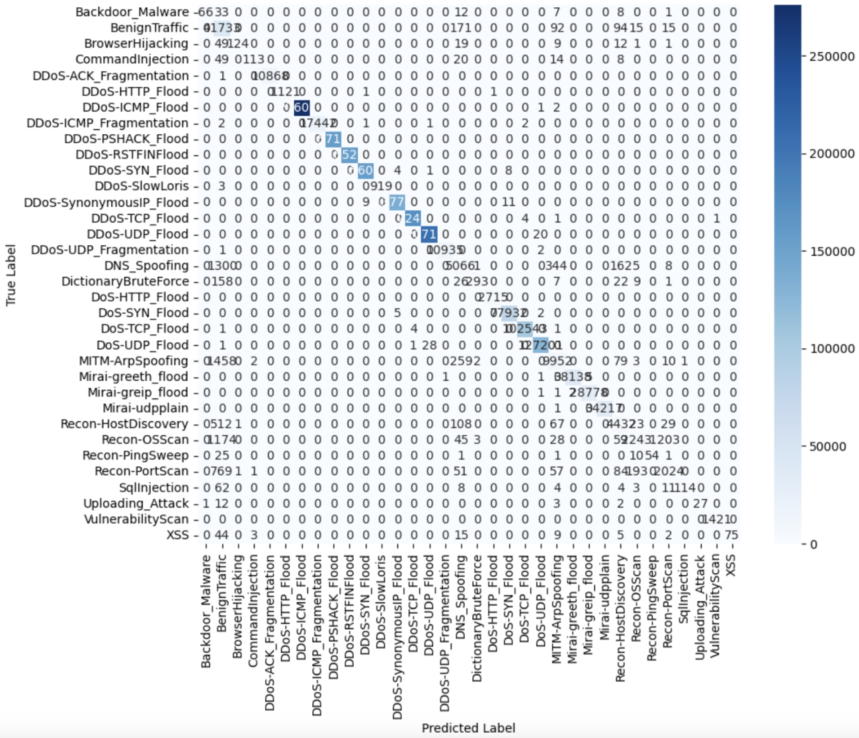

Figure 4.6- Confusion matrix of the Random Subspace classifier

### 4.4.6. Ensemble Bayesian Model Averaging

The Ensemble Bayesian Model Averaging combines RF and DNN models through averaging their predictions. By leveraging the diverse predictions of these two models, it achieves improved accuracy and generalisation across different classes. This ensemble method excels in cases where individual models have complementary strengths and weaknesses. However, it may still face challenges in scenarios where both base models misclassify the same instances, leading to limited improvement in overall performance. Table 4.5 presents the result of the model’s evaluation and Figure 4.7 present the confusion matrix of the classifier.

Table 4.6 Ensemble Bayesian Model Averaging Evaluation result

|  |  |  |  |
| --- | --- | --- | --- |
| **Class** | precision | recall | f1-score |
| Backdoor_Malware | 0.67 | 0.03 | 0.06 |
| BenignTraffic | 0.84 | 0.99 | 0.91 |
| BrowserHijacking | 0.92 | 0.11 | 0.2 |
| CommandInjection | 0.95 | 0.18 | 0.3 |
| DDoS-ACK_Fragmentation | 1 | 0.99 | 0.99 |
| DDoS-HTTP_Flood | 0.96 | 0.84 | 0.9 |
| DDoS-ICMP_Flood | 1 | 1 | 1 |
| DDoS-ICMP_Fragmentation | 0.99 | 1 | 1 |
| DDoS-PSHACK_Flood | 1 | 1 | 1 |
| DDoS-RSTFINFlood | 1 | 1 | 1 |
| DDoS-SYN_Flood | 1 | 1 | 1 |
| DDoS-SlowLoris | 0.91 | 0.96 | 0.94 |
| DDoS-SynonymousIP_Flood | 1 | 1 | 1 |
| DDoS-TCP_Flood | 1 | 1 | 1 |
| DDoS-UDP_Flood | 0.99 | 1 | 1 |
| DDoS-UDP_Fragmentation | 0.99 | 0.99 | 0.99 |
| DNS_Spoofing | 0.84 | 0.67 | 0.74 |
| DictionaryBruteForce | 1 | 0.19 | 0.32 |
| DoS-HTTP_Flood | 0.94 | 0.98 | 0.96 |
| DoS-SYN_Flood | 1 | 1 | 1 |
| DoS-TCP_Flood | 1 | 1 | 1 |
| DoS-UDP_Flood | 1 | 0.99 | 0.99 |
| MITM-ArpSpoofing | 0.9 | 0.81 | 85 |
| Mirai-greeth_flood | 1 | 1 | 1 |
| Mirai-greip_flood | 1 | 1 | 1 |
| Mirai-udpplain | 1 | 1 | 1 |
| Recon-HostDiscovery | 0.81 | 0.83 | 0.82 |
| Recon-OSScan | 0.87 | 0.36 | 0.51 |
| Recon-PingSweep | 0.6 | 0.03 | 0.06 |
| Recon-PortScan | 0.85 | 0.48 | 0.61 |
| SqlInjection | 0.9 | 0.09 | 0.16 |
| Uploading_Attack | 0 | 0 | 0 |
| VulnerabilityScan | 0.92 | 0.99 | 0.95 |
| XSS | 0.8 | 0.03 | 0.05 |
| **Accuracy** | **0.9918** | | |

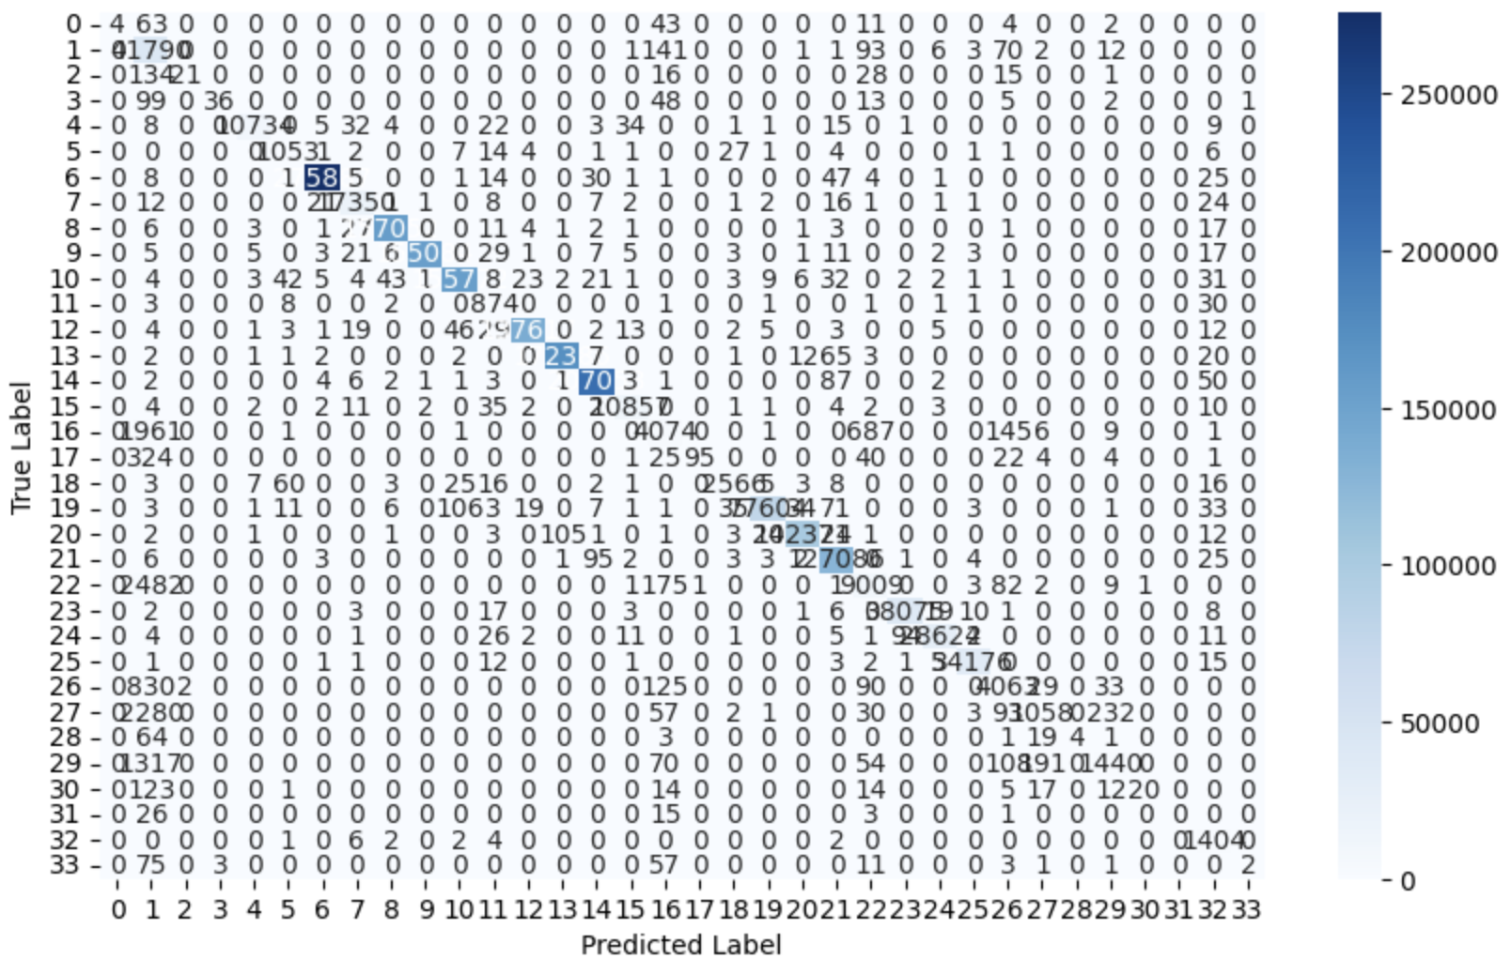

Figure 4.7- Confusion matrix of the combine RF and DNN classifier using Bayesian averaging.

### 4.4.7. Ensemble Boosting

The Ensemble Boosting method, specifically AdaBoost, aims to improve model performance by iteratively training weak learners on misclassified instances. However, in this context, it shows limited effectiveness in enhancing overall performance compared to other ensemble methods. AdaBoost may struggle to capture complex patterns present in intrusion detection data, leading to suboptimal precision and recall scores across different classes. As a result, it may not be the most suitable choice for intrusion detection systems where accuracy and generalization are paramount. Table 4.6 presents the result of the model’s evaluation and Figure 4.8 present the confusion matrix of the classifier.

Table 4.8 Ensemble Boosting Evaluation result

|  |  |  |  |
| --- | --- | --- | --- |
| **Class** | precision | recall | f1-score |
| Backdoor_Malware | 0 | 0 | 0 |
| BenignTraffic | 0.98 | 0.5 | 0.66 |
| BrowserHijacking | 0 | 0 | 0 |
| CommandInjection | 0 | 0 | 0 |
| DDoS-ACK_Fragmentation | 0.85 | 0.88 | 0.87 |
| DDoS-HTTP_Flood | 0 | 0.16 | 0 |
| DDoS-ICMP_Flood | 0.65 | 0 | 0.1 |
| DDoS-ICMP_Fragmentation | 1 | 0.97 | 0.98 |
| DDoS-PSHACK_Flood | 1 | 0.96 | 0.98 |
| DDoS-RSTFINFlood | 1 | 0.06 | 0.11 |
| DDoS-SYN_Flood | 0.62 | 0.02 | 0.04 |
| DDoS-SlowLoris | 0 | 0 | 0 |
| DDoS-SynonymousIP_Flood | 0.96 | 0.96 | 0.96 |
| DDoS-TCP_Flood | 0.58 | 0.02 | 0.04 |
| DDoS-UDP_Flood | 0.36 | 0.97 | 0.52 |
| DDoS-UDP_Fragmentation | 0.22 | 0.85 | 0.35 |
| DNS_Spoofing | 0.95 | 0.5 | 0.66 |
| DictionaryBruteForce | 1 | 0 | 0 |
| DoS-HTTP_Flood | 0.2 | 0.91 | 0.33 |
| DoS-SYN_Flood | 0.15 | 0.93 | 0.27 |
| DoS-TCP_Flood | 0.34 | 0.07 | 0.12 |
| DoS-UDP_Flood | 0.9 | 0.25 | 0.39 |
| MITM-ArpSpoofing | 0.98 | 0.51 | 0.67 |
| Mirai-greeth_flood | 0.57 | 0.99 | 0.73 |
| Mirai-greip_flood | 0.42 | 0.01 | 0.01 |
| Mirai-udpplain | 0.47 | 0.01 | 0.01 |
| Recon-HostDiscovery | 1 | 0.5 | 0.67 |
| Recon-OSScan | 0.92 | 0.5 | 0.65 |
| Recon-PingSweep | 0 | 0.51 | 0 |
| Recon-PortScan | 0.59 | 0.59 | 0.59 |
| SqlInjection | 0 | 0.1 | 0 |
| Uploading_Attack | 0 | 0 | 0 |
| VulnerabilityScan | 0.12 | 0.99 | 0.21 |
| XSS | 0.67 | 0.51 | 0.58 |
| **Accuracy** | **0.41** | | |

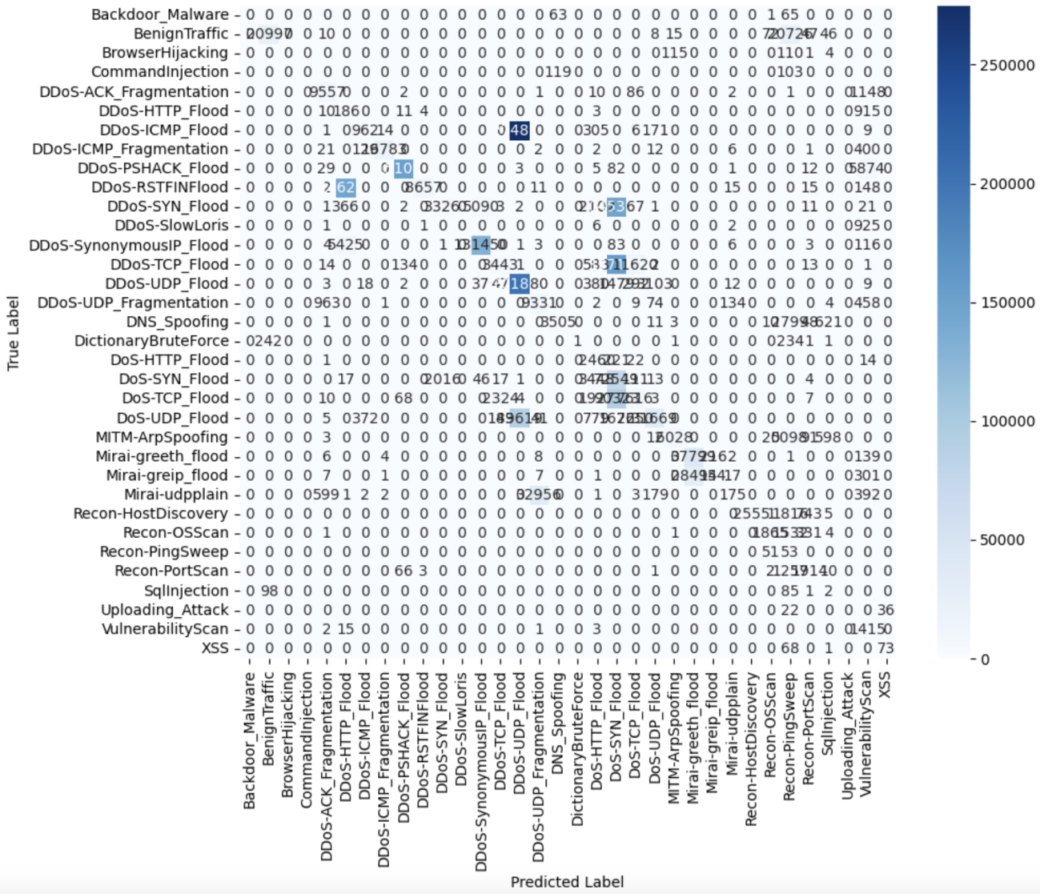

Figure 4.8 - Adaboost classifier confusion matrix

### 4.4.8. Model Comparison.

Table 4.7 combines and compares each model's evaluation results. Based on the evaluation metrics, the following observations can be made:

* **Random Forest**: Performs well across various classes with high accuracy, particularly suitable for cases where precision and recall are balanced.
* **DNN (Deep Neural Network)**: Shows satisfactory performance in some classes but struggles with others, leading to a lower overall accuracy compared to Random Forest.
* **Ensemble Voting Method**: Combining Naive Bayes and Logistic Regression through voting. It performs poorly compared to other methods, likely due to the simplistic nature of the base models.
* **Ensemble Random Subspace Method**: Achieves high accuracy and balanced performance across classes, making it suitable for general-purpose intrusion detection.
* **Ensemble Bayesian Model Averaging**: combining RF and DNN improves performance, especially in balancing precision and recall.
* **Ensemble Boosting**: Shows limited effectiveness in improving overall performance, particularly in comparison to other ensemble methods.

Table 4.9 Different model evaluation results

|  |  |  |  |  |  |  |  |  |  |  |  |  |  |  |  |  |  |  |
| --- | --- | --- | --- | --- | --- | --- | --- | --- | --- | --- | --- | --- | --- | --- | --- | --- | --- | --- |
|  | **Random Forest** | | | **DNN** | | | **Bayesian Model Averaging** | | | **Ensemble Random Subspace Method** | | | **Ensemble Voting** | | | **Ensemble Boosting** | | |
| **Class** | precision | recall | f1-score | precision | recall | f1-score | precision | recall | f1-score | precision | recall | f1-score | precision | recall | f1-score | precision | recall | f1-score |
| Backdoor_Malware | 0.86 | 0.14 | 0.24 | 0 | 0 | 0 | 0.67 | 0.03 | 0.06 | 1 | 0.53 | 0.69 | 0 | 0.32 | 0 | 0 | 0 | 0 |
| BenignTraffic | 0.89 | 0.99 | 0.94 | 0.72 | 0.95 | 0.82 | 0.84 | 0.99 | 0.91 | 0.89 | 0.99 | 0.94 | 0.65 | 0.09 | 0.15 | 0.98 | 0.5 | 0.66 |
| BrowserHijacking | 0.89 | 0.26 | 0.4 | 0 | 0 | 0 | 0.92 | 0.11 | 0.2 | 0.97 | 0.59 | 0.73 | 0.01 | 0.06 | 0.01 | 0 | 0 | 0 |
| CommandInjection | 0.81 | 0.28 | 0.42 | 0 | 0 | 0 | 0.95 | 0.18 | 0.3 | 0.97 | 0.56 | 0.71 | 0 | 0.21 | 0 | 0 | 0 | 0 |
| DDoS-ACK_Fragmentation | 1 | 0.99 | 0.99 | 0.99 | 0.98 | 0.99 | 1 | 0.99 | 0.99 | 1 | 1 | 1 | 0.01 | 0.06 | 0.01 | 0.85 | 0.88 | 0.87 |
| DDoS-HTTP_Flood | 0.99 | 0.98 | 0.98 | 0.91 | 0.57 | 0.7 | 0.96 | 0.84 | 0.9 | 1 | 1 | 1 | 1 | 0.79 | 0.88 | 0 | 0.16 | 0 |
| DDoS-ICMP_Flood | 1 | 1 | 1 | 1 | 1 | 1 | 1 | 1 | 1 | 1 | 1 | 1 | 0.49 | 0.58 | 0.53 | 0.65 | 0 | 0.1 |
| DDoS-ICMP_Fragmentation | 0.99 | 1 | 1 | 1 | 0.97 | 0.99 | 0.99 | 1 | 1 | 1 | 1 | 1 | 1 | 1 | 1 | 1 | 0.97 | 0.98 |
| DDoS-PSHACK_Flood | 1 | 1 | 1 | 1 | 1 | 1 | 1 | 1 | 1 | 1 | 1 | 1 | 0.99 | 0.97 | 0.98 | 1 | 0.96 | 0.98 |
| DDoS-RSTFINFlood | 1 | 1 | 1 | 1 | 1 | 1 | 1 | 1 | 1 | 1 | 1 | 1 | 1 | 0.98 | 0.99 | 1 | 0.06 | 0.11 |
| DDoS-SYN_Flood | 1 | 1 | 1 | 1 | 1 | 1 | 1 | 1 | 1 | 1 | 1 | 1 | 1 | 1 | 1 | 0.62 | 0.02 | 0.04 |
| DDoS-SlowLoris | 0.92 | 0.99 | 0.96 | 0.55 | 0.46 | 0.5 | 0.91 | 0.96 | 0.94 | 1 | 1 | 1 | 0.61 | 0.1 | 0.18 | 0 | 0 | 0 |
| DDoS-SynonymousIP_Flood | 1 | 1 | 1 | 1 | 1 | 1 | 1 | 1 | 1 | 1 | 1 | 1 | 0.34 | 0.52 | 0.41 | 0.96 | 0.96 | 0.96 |
| DDoS-TCP_Flood | 1 | 1 | 1 | 1 | 1 | 1 | 1 | 1 | 1 | 1 | 1 | 1 | 0.41 | 0.99 | 0.58 | 0.58 | 0.02 | 0.04 |
| DDoS-UDP_Flood | 1 | 1 | 1 | 1 | 1 | 1 | 0.99 | 1 | 1 | 1 | 1 | 1 | 0.98 | 0.02 | 0.04 | 0.36 | 0.97 | 0.52 |
| DDoS-UDP_Fragmentation | 1 | 0.99 | 1 | 1 | 0.94 | 0.97 | 0.99 | 0.99 | 0.99 | 1 | 1 | 1 | 0.23 | 0 | 0 | 0.22 | 0.85 | 0.35 |
| DNS_Spoofing | 0.83 | 0.75 | 0.79 | 0.6 | 0.08 | 0.15 | 0.84 | 0.67 | 0.74 | 0.87 | 0.75 | 0.8 | 0.14 | 0 | 0 | 0.95 | 0.5 | 0.66 |
| DictionaryBruteForce | 0.97 | 0.44 | 0.6 | 0 | 0 | 0 | 1 | 0.19 | 0.32 | 0.98 | 0.57 | 0.72 | 0.48 | 0.18 | 0.26 | 1 | 0 | 0 |
| DoS-HTTP_Flood | 0.99 | 1 | 1 | 0.91 | 0.9 | 0.9 | 0.94 | 0.98 | 0.96 | 1 | 1 | 1 | 0.18 | 0.84 | 0.29 | 0.2 | 0.91 | 0.33 |
| DoS-SYN_Flood | 1 | 1 | 1 | 0.99 | 0.99 | 0.99 | 1 | 1 | 1 | 1 | 1 | 1 | 0.8 | 0.11 | 0.19 | 0.15 | 0.93 | 0.27 |
| DoS-TCP_Flood | 1 | 1 | 1 | 1 | 0.99 | 0.99 | 1 | 1 | 1 | 1 | 1 | 1 | 0.37 | 0.99 | 0.54 | 0.34 | 0.07 | 0.12 |
| DoS-UDP_Flood | 1 | 1 | 1 | 0.99 | 1 | 0.99 | 1 | 0.99 | 0.99 | 1 | 1 | 1 | 0.38 | 0.99 | 0.55 | 0.9 | 0.25 | 0.39 |
| MITM-ArpSpoofing | 0.91 | 0.85 | 0.88 | 0.78 | 0.51 | 0.61 | 0.9 | 0.81 | 85 | 0.94 | 0.85 | 0.89 | 0.91 | 0.13 | 0.23 | 0.98 | 0.51 | 0.67 |
| Mirai-greeth_flood | 1 | 1 | 1 | 0.99 | 0.97 | 0.98 | 1 | 1 | 1 | 1 | 1 | 1 | 0.58 | 0.99 | 0.73 | 0.57 | 0.99 | 0.73 |
| Mirai-greip_flood | 1 | 1 | 1 | 0.96 | 0.97 | 0.97 | 1 | 1 | 1 | 1 | 1 | 1 | 0.66 | 0.02 | 0.03 | 0.42 | 0.01 | 0.01 |
| Mirai-udpplain | 1 | 1 | 1 | 1 | 0.99 | 0.99 | 1 | 1 | 1 | 1 | 1 | 1 | 1 | 0.98 | 0.99 | 0.47 | 0.01 | 0.01 |
| Recon-HostDiscovery | 0.87 | 0.86 | 0.87 | 0.41 | 0.53 | 0.46 | 0.81 | 0.83 | 0.82 | 0.89 | 0.87 | 0.88 | 0.92 | 0.94 | 0.24 | 1 | 0.5 | 0.67 |
| Recon-OSScan | 0.84 | 0.6 | 0.7 | 0.33 | 0 | 0 | 0.87 | 0.36 | 0.51 | 0.9 | 0.61 | 0.73 | 0.05 | 0.02 | 0.04 | 0.92 | 0.5 | 0.65 |
| Recon-PingSweep | 0.5 | 0.03 | 0.6 | 0 | 0 | 0 | 0.6 | 0.03 | 0.06 | 1 | 0.59 | 0.74 | 0.2 | 0.18 | 0.19 | 0 | 0.51 | 0 |
| Recon-PortScan | 0.83 | 0.64 | 0.72 | 0.42 | 0.09 | 0.15 | 0.85 | 0.48 | 0.61 | 0.87 | 0.65 | 0.74 | 0.03 | 0.08 | 0.04 | 0.59 | 0.59 | 0.59 |
| SqlInjection | 0.92 | 0.21 | 0.35 | 0 | 0 | 0 | 0.9 | 0.09 | 0.16 | 0.98 | 0.55 | 0.75 | 0.18 | 0 | 0.01 | 0 | 0.1 | 0 |
| Uploading_Attack | 0.5 | 0.02 | 0.04 | 0 | 0 | 0 | 0 | 0 | 0 | 1 | 0.6 | 0.75 | 0.01 | 0.11 | 0.01 | 0 | 0 | 0 |
| VulnerabilityScan | 0.96 | 0.99 | 0.98 | 0.18 | 0.98 | 0.31 | 0.92 | 0.99 | 0.95 | 1 | 1 | 1 | 0 | 0.91 | 0 | 0.12 | 0.99 | 0.21 |
| XSS | 0.58 | 0.14 | 0.22 | 0 | 0 | 0 | 0.8 | 0.03 | 0.05 | 1 | 0.49 | 0.66 | 0.01 | 0.04 | 0.01 | 0.67 | 0.51 | 0.58 |
| **Accuracy** | **0.9947** | | | **0.965** | | | **0.9918** | | | **0.9955** | | | **0.6101** | | | **0.41** | | |

For use cases where a balance between precision and recall is critical, such as in intrusion detection systems, the **Ensemble Random Subspace Method** appears to be the most suitable choice due to its consistently high performance across different classes. However, depending on specific requirements and computational constraints, other ensemble methods like the **Bayesian Model Averaging** could also be considered.

### 4.4.9. Visual Representation

Figure 4.1 present a bar chart depicting the accuracy of each model showcases the Ensemble Random Subspace Method as the top performer, followed closely by the Random Forest model, while the Bayesian averaging algorithm exhibits the lowest accuracy among the evaluated models.

Figure 4.9 - Bar chart representation of the different algorithm accuracy.

## 4.5. Deployment

### 4.5.1. Research Question 3

Can ML accurately distinguish between regular network activity and harmful operations in IoT environments?

### 4.5.2. Answer 3

ML holds considerable promise in accurately distinguishing between regular network activity and harmful operations in IoT environments, as evidenced by the different model evaluations. The results presented in this study indicate that ML models, particularly ensemble methods such as Random Forest and the Ensemble Random Subspace Method, demonstrate high accuracy in classifying network traffic and detecting malicious activities in IoT networks.

One key aspect supporting ML's effectiveness in this context is its ability to analyze large volumes of heterogeneous data generated by IoT devices. Traditional rule-based approaches often struggle to handle the complexity and diversity of IoT data streams, whereas ML algorithms excel at extracting meaningful patterns and features from such datasets. For example, the Random Forest model, as presented in the result of the evaluation, has shown robust performance in accurately identifying various types of attacks, including DDoS attacks and malware infections, amidst benign IoT traffic.

Moreover, the Ensemble Random Subspace Method, which leverages multiple models trained on different subsets of features, further enhances the accuracy and robustness of intrusion detection systems in IoT environments. By combining the strengths of different models, this ensemble approach effectively mitigates overfitting and captures diverse attack patterns, thereby improving overall detection performance. The research results indicate that this method consistently achieves high precision and recall scores across a wide range of attack scenarios, making it well-suited for real-world deployment in IoT security applications.

Furthermore, the adaptability of ML models to evolving threats is a significant advantage in IoT security. ML algorithms can continuously learn and adapt to new attack patterns and variations, ensuring that IoT networks remain protected against emerging threats. This dynamic nature of ML-based intrusion detection systems enables proactive threat mitigation and reduces the reliance on static rule sets, which may quickly become outdated in the face of rapidly evolving attack strategies.

In conclusion, the research findings strongly support the assertion that ML can accurately distinguish between regular network activity and harmful operations in IoT environments. The demonstrated success of ML models, particularly ensemble methods like Random Forest and the Ensemble Random Subspace Method, underscores their potential to significantly enhance the security posture of IoT networks by providing effective and adaptable intrusion detection capabilities. As IoT continues to proliferate across various domains, ML-based approaches are poised to play a crucial role in safeguarding these interconnected ecosystems against emerging cyber threats.

# Chapter 5 - Discussion

In this chapter presents a comprehensive discussion of the findings presented in the preceding chapters, addressing the research questions and objectives outlined in the introduction. The discussion is structured around key themes and insights derived from the analysis, shedding light on the implications of the research and its contributions to the field.

## 5.1. Effectiveness of Machine Learning Models

The evaluation of various ML models, including Random Forest, Deep Neural Network, Ensemble Voting Method, Ensemble Random Subspace Method, Ensemble Bayesian Model Averaging, and Ensemble Boosting, revealed varying levels of effectiveness in distinguishing between regular network activity and harmful operations in IoT environments. While some models exhibited high accuracy and robustness, others struggled with certain types of attacks or suffered from overfitting issues. The Ensemble Random Subspace Method emerged as the top performer, showcasing consistent and balanced performance across different attack scenarios.

## 5.2. Strengths and Weaknesses of ML Approaches

Each ML approach demonstrated unique strengths and weaknesses in the context of IoT security. Ensemble methods, such as the Ensemble Random Subspace Method, leveraged the diversity of base models to improve overall detection performance and mitigate the impact of noisy or imbalanced data. However, models like the Ensemble Boosting method exhibited limited effectiveness in enhancing accuracy, highlighting the importance of selecting appropriate algorithms based on the characteristics of the dataset and the nature of the attacks.

Ensemble methods, such as the Ensemble Random Subspace Method, offer several advantages in IoT security:

* **Improved Performance**: By combining predictions from multiple base models trained on different subsets of features, ensemble methods can enhance overall detection performance. They leverage the diversity of individual models to capture a wide range of attack patterns and mitigate the impact of noisy or imbalanced data.
* **Robustness**: Ensemble methods are inherently robust against overfitting and model variance. By aggregating the predictions of diverse models, they can achieve more stable and reliable results, even in the presence of outliers or erroneous data.
* **Flexibility**: Ensemble methods are flexible and adaptable to different types of attacks and datasets. They can incorporate various base models, including decision trees, neural networks, and logistic regression, allowing for customization based on the specific characteristics of the IoT environment.

While ensemble methods generally offer promising results, not all ML models perform equally well in IoT security applications:

* **Ensemble Boosting Method**: Some models, such as the Ensemble Boosting method, may exhibit limited effectiveness in enhancing accuracy. This could be attributed to factors such as the complexity of the dataset, the nature of the attacks, or the inherent limitations of the boosting algorithm in capturing subtle patterns in the data.
* **Overfitting Concerns**: Certain ML models, including deep neural networks, may be prone to overfitting, especially when trained on large and complex datasets. This can lead to a discrepancy between training and testing performance, compromising the model's generalization capabilities in real-world scenarios.

## 5.3. Challenges and Opportunities in IoT Security

The research identified several challenges and opportunities in IoT security that warrant further investigation. These include the need for robust anomaly detection techniques capable of handling the dynamic and heterogeneous nature of IoT data streams, as well as the development of lightweight and energy-efficient ML models suitable for deployment on resource-constrained IoT devices. Additionally, addressing privacy and ethical concerns related to data collection and model deployment remains a crucial aspect of IoT security research.

### 5.3.1. Dynamic and Heterogeneous Data Streams

* Challenge: IoT environments generate vast amounts of data from diverse sources, including sensors, actuators, and communication protocols. The dynamic and heterogeneous nature of these data streams pose challenges for traditional anomaly detection techniques, which may struggle to adapt to evolving patterns and detect subtle deviations indicative of malicious activities.
* Opportunity: Developing robust anomaly detection techniques capable of effectively analyzing and contextualizing diverse IoT data streams is essential for enhancing the security posture of IoT ecosystems. This involves exploring advanced ML algorithms, such as deep learning and ensemble methods, that can learn from the temporal and spatial correlations present in IoT data to accurately identify anomalous behavior.

### 5.3.2. Resource Constraints on IoT Devices

* Challenge: Many IoT devices operate under resource-constrained environments with limited computational power, memory, and energy resources. This poses challenges for deploying sophisticated ML models that require significant computational resources for training and inference.
* Opportunity: There is a need for the development of lightweight and energy-efficient ML models tailored for deployment on resource-constrained IoT devices. This involves optimizing model architectures, implementing efficient algorithms, and exploring techniques such as model compression and quantization to reduce the computational and memory footprint of ML models without sacrificing accuracy.

### 5.3.3. Privacy and Ethical Concerns

* + Challenge: IoT deployments raise significant privacy and ethical concerns related to data collection, storage, and analysis. The proliferation of IoT devices collecting sensitive information about individuals' behaviors, preferences, and activities raises questions about data ownership, consent, and privacy protection.
  + Opportunity: Addressing privacy and ethical concerns requires a multidisciplinary approach that integrates principles of privacy-by-design, data anonymization, and transparent governance frameworks into the design and deployment of IoT systems. ML techniques such as federated learning and differential privacy offer promising avenues for preserving data privacy while enabling collaborative and decentralized analysis of IoT data.

The challenges and opportunities in IoT security underscore the need for interdisciplinary research efforts aimed at developing innovative solutions to address the complexities of securing IoT ecosystems. By leveraging advanced ML techniques, optimizing resource utilization, and prioritizing privacy and ethical considerations, researchers and practitioners can work towards building resilient and trustworthy IoT systems capable of mitigating emerging cyber threats while safeguarding individuals' privacy and autonomy.

## 5.4. Implications for Practice and Policy

This research's findings have significant implications for practice and policy in the IoT security domain. Practitioners can leverage the insights gained from the evaluation of ML models to inform the design and implementation of intrusion detection systems tailored to IoT environments. Moreover, policymakers can use the research findings to advocate for the adoption of standardized security protocols and regulations aimed at enhancing the resilience of IoT ecosystems against cyber threats.

In conclusion, while ensemble methods like the Ensemble Random Subspace Method demonstrate notable strengths in enhancing IoT security through improved detection performance and robustness, challenges remain in selecting the most effective ML algorithms and mitigating the limitations associated with certain models. Future research efforts should focus on developing novel approaches to address these challenges and further enhance the effectiveness of ML-based intrusion detection systems in IoT environments.

# Chapter 6 – Conclusion and Future Work

## 6.1. Conclusion

The findings of this research provide valuable insights into the efficacy of various ML models for distinguishing between regular network activity and harmful operations in IoT environments. Through comprehensive evaluation and analysis, it was observed that ensemble methods, particularly the Ensemble Random Subspace Method, exhibited superior performance in terms of accuracy and robustness. These results underscore the potential of ML-based intrusion detection systems to enhance the security posture of IoT ecosystems by effectively detecting and mitigating cyber threats.

## 6.2. Limitation of Study

While the research presented promising outcomes, several limitations warrant acknowledgment. Firstly, the evaluation was conducted using a specific dataset and may not fully capture the diversity of IoT environments and attack scenarios. Additionally, the performance of ML models may be influenced by factors such as data pre-processing techniques, hyperparameter tuning, and feature selection methods, which were not exhaustively explored in this study. Furthermore, the evaluation focused primarily on supervised learning approaches, and future research should explore the potential of unsupervised and semi-supervised techniques for IoT security. Moreover, due to the huge size of the dataset, a subset was used for training and evaluation, as processing the entire dataset presented computation limitations in terms of processing power and memory for the computers running the model.

## 6.3. Future Work

Building upon the insights gained from this research, several avenues for future investigation emerge:

* Exploration of Novel ML Techniques: Future research should explore the efficacy of novel ML techniques, such as reinforcement learning and meta-learning approaches, for IoT security applications. These techniques may offer improved capabilities for detecting complex and evolving cyber threats in IoT environments.
* Integration of Domain Knowledge: Incorporating domain knowledge and expert insights into ML models can enhance their interpretability and generalization capabilities. Future work should focus on developing hybrid approaches that leverage both data-driven techniques and domain-specific knowledge for more effective intrusion detection in IoT networks.
* Addressing Emerging Threats: With the evolving threat landscape, continuous monitoring and adaptation of intrusion detection systems are essential. Future work should focus on developing adaptive and self-learning ML models capable of detecting and mitigating emerging cyber threats in real-time.

# References

Adat, V. and Gupta, B. B. (2018) ‘Security in Internet of Things: issues, challenges, taxonomy, and architecture.’ *Telecommunication Systems*, 67(3) pp. 423–441.

Ahmed, S. and Khan, M. (2023) ‘Securing the Internet of Things (IoT): A Comprehensive Study on the Intersection of Cybersecurity, Privacy, and Connectivity in the IoT Ecosystem.’ *AI, IoT and the Fourth Industrial Revolution Review*, 13(9) pp. 1–17.

Al-Fuqaha, A., Guizani, M., Mohammadi, M., Aledhari, M. and Ayyash, M. (2015) ‘Internet of Things: A Survey on Enabling Technologies, Protocols, and Applications.’ *IEEE Communications Surveys & Tutorials*, 17(4) pp. 2347–2376.

Antonakakis, M., April, T., Bailey, M., Bernhard, M., Bursztein, E., Cochran, J., Durumeric, Z., Halderman, J. A., Invernizzi, L., Kallitsis, M., Kumar, D., Lever, C., Ma, Z., Mason, J., Menscher, D., Seaman, C., Sullivan, N., Thomas, K. and Zhou, Y. (2017) ‘Understanding the Mirai Botnet.’ *In*, pp. 1093–1110.

Ashok, A., Acharya, Kumar B J, S. and J, B. (2020) ‘An Intrusion Detection System Against UDP Flood Attack and Ping of Death Attack (DDOS) in MANET.’ *International Journal of Engineering Technologies IJET*, December.

Babu, P., Bhaskari, L., and CH.Satyanarayana (2011) ‘A Comprehensive Analysis of Spoofing.’ *International Journal of Advanced Computer Sciences and Applications*, January.

Bakhsh, S. A., Khan, M. A., Ahmed, F., Alshehri, M. S., Ali, H. and Ahmad, J. (2023) ‘Enhancing IoT network security through deep learning-powered Intrusion Detection System.’ *Internet of Things*, 24, December, p. 100936.

Bošnjak, L., Sres, J. and Brumen, B. (2018) *Brute-force and dictionary attack on hashed real-world passwords*, p. 1166.

Breiman, L. (2001) ‘Random Forests.’ *Machine Learning*, 45(1) pp. 5–32.

Cebeloglu, F. S. and Karakose, M. (2019) ‘A Cyber Security Analysis Used for Unmanned Aerial Vehicles in the Smart City.’ *In* *2019 1st International Informatics and Software Engineering Conference (UBMYK)*, pp. 1–6.

deRito, C. and Bhatia, S. (2022) ‘Comparative Analysis of Open-Source Vulnerability Scanners for IoT Devices.’ *In* Hemanth, D. J., Pelusi, D., and Vuppalapati, C. (eds) *Intelligent Data Communication Technologies and Internet of Things*. Singapore: Springer Nature (Lecture Notes on Data Engineering and Communications Technologies), pp. 785–800.

Dietterich, T. G. (2000) ‘Ensemble Methods in Machine Learning.’ *In* *Multiple Classifier Systems*. Berlin, Heidelberg: Springer, pp. 1–15.

Domb, M., Joshi, S., Khn, A., Domb, M., Joshi, S. and Khn, A. (2023) ‘Anomaly Detection in IoT: Recent Advances, AI and ML Perspectives and Applications.’ *In* *Anomaly Detection - Recent Advances, AI and ML Perspectives and Applications*. IntechOpen.

Duravkin, I., Loktionova, A. and Carlsson, A. (2014) ‘Method of slow-attack detection.’ *In* *2014 First International Scientific-Practical Conference Problems of Infocommunications Science and Technology*, pp. 171–172.

Egon, A. and Potter, K. (2023) ‘Privacy and Ethical Implications of IoT Data Collection and Usage.’ *Journal of Computer Science*, December.

García-Teodoro, P., Díaz-Verdejo, J., Maciá-Fernández, G. and Vázquez, E. (2009) ‘Anomaly-based network intrusion detection: Techniques, systems and challenges.’ *Computers & Security*, 28(1) pp. 18–28.

Grover, V. and Gagandeep (2020) ‘An Efficient Brute Force Attack Handling Techniques for Server Virtualization.’ Rochester, NY.

Gupta, S. and Gupta, B. B. (2017) ‘Cross-Site Scripting (XSS) attacks and defense mechanisms: classification and state-of-the-art.’ *International Journal of System Assurance Engineering and Management*, 8(1) pp. 512–530.

HaddadPajouh, H., Dehghantanha, A., M. Parizi, R., Aledhari, M. and Karimipour, H. (2021) ‘A survey on internet of things security: Requirements, challenges, and solutions.’ *Internet of Things*, 14, June, p. 100129.

Hameed, S., Khan, F. I. and Hameed, B. (2019) ‘Understanding Security Requirements and Challenges in Internet of Things (IoT): A Review.’ *Journal of Computer Networks and Communications*. Hindawi, 2019, January, p. e9629381.

Hanif, S., Ilyas, T. and Zeeshan, M. (2019) ‘Intrusion Detection In IoT Using Artificial Neural Networks On UNSW-15 Dataset.’ *In* *2019 IEEE 16th International Conference on Smart Cities: Improving Quality of Life Using ICT & IoT and AI (HONET-ICT)*, pp. 152–156.

Harshita, H. (2017) ‘Detection and Prevention of ICMP Flood DDOS Attack.’ *International Journal of New Technology and Research*. Nextgen Research Publication, 3(3) p. 263333.

Jackson, J. and Rahman, S. (2019) ‘Exploring Challenges and Opportunities in Cybersecurity Risk and Threat Communications Related To The Medical Internet Of Things (MIoT).’ arXiv.

Kayode Saheed, Y., Idris Abiodun, A., Misra, S., Kristiansen Holone, M. and Colomo-Palacios, R. (2022) ‘A machine learning-based intrusion detection for detecting internet of things network attacks.’ *Alexandria Engineering Journal*, 61(12) pp. 9395–9409.

Kazienko, P., Lughofer, E. and Trawiński, B. (2013) ‘Hybrid and Ensemble Methods in Machine Learning J.UCS Special Issue.’

Kilincer, I. F., Ertam, F. and Sengur, A. (2021) ‘Machine learning methods for cyber security intrusion detection: Datasets and comparative study.’ *Computer Networks*, 188, April, p. 107840.

Kizza, J. M. (2024) ‘System Intrusion Detection and Prevention.’ *In* Kizza, J. M. (ed.) *Guide to Computer Network Security*. Cham: Springer International Publishing (Texts in Computer Science), pp. 295–323.

Lin, W., Yin, X., Wang, S. and Khosravi, M. R. (2020) ‘A Blockchain-enabled decentralized settlement model for IoT data exchange services.’ *Wireless Networks*, May.

Loi, H. and Olmsted, A. (2017) ‘Low-cost detection of backdoor malware.’ *In* *2017 12th International Conference for Internet Technology and Secured Transactions (ICITST)*, pp. 197–198.

Mishra, M., Mishra, V. K., Tekale, S., NagaPraveena, T., Parijatha, K., Dewangan, B. and Hadimani, S. (2023) ‘Machine Learning Security Algorithms and Framework for IOT System.’ *In* *2022 OPJU International Technology Conference on Emerging Technologies for Sustainable Development (OTCON)*, pp. 1–6.

Neto, E. C. P., Dadkhah, S., Ferreira, R., Zohourian, A., Lu, R. and Ghorbani, A. A. (2023) ‘CICIoT2023: A Real-Time Dataset and Benchmark for Large-Scale Attacks in IoT Environment.’ *Sensors*. Multidisciplinary Digital Publishing Institute, 23(13) p. 5941.

Nilashi, M., Abumalloh, R. A., Minaei-Bidgoli, B., Samad, S., Yousoof Ismail, M., Alhargan, A. and Abdu Zogaan, W. (2022) ‘Predicting Parkinson’s Disease Progression: Evaluation of Ensemble Methods in Machine Learning.’ *Journal of Healthcare Engineering*, 2022, February, p. 2793361.

Öner, M. and Sin, G. (2021) ‘Data-Driven Control Strategies for the Autonomous Operation of the Pharmaceutical Crystallization Process.’ *In* Türkay, M. and Gani, R. (eds) *Computer Aided Chemical Engineering*. Elsevier (31 European Symposium on Computer Aided Process Engineering), pp. 1271–1276.

Othman, S. M., Ba-Alwi, F. M., Alsohybe, N. T. and Al-Hashida, A. Y. (2018) ‘Intrusion detection model using machine learning algorithm on Big Data environment.’ *Journal of Big Data*, 5(1) p. 34.

Owens, J. and Matthews, J. (n.d.) ‘A Study of Passwords and Methods Used in Brute-Force SSH Attacks.’

Ozsahin, D. U., Taiwo Mustapha, M., Mubarak, A. S., Said Ameen, Z. and Uzun, B. (2022) ‘Impact of feature scaling on machine learning models for the diagnosis of diabetes.’ *In* *2022 International Conference on Artificial Intelligence in Everything (AIE)*, pp. 87–94.

Pacheco, J., Benitez, V. H., Félix-Herrán, L. C. and Satam, P. (2020) ‘Artificial Neural Networks-Based Intrusion Detection System for Internet of Things Fog Nodes.’ *IEEE Access*, 8 pp. 73907–73918.

Patidar, S., Parihar, P. and Agrawal, C. (2020) ‘A Review of Intrusion Detection Datasets and Techniques.’ *SMART MOVES JOURNAL IJOSCIENCE*, 6(3) pp. 14–22.

Raptis, G. E., Katsini, C. and Alexakos, C. (2021) ‘Towards Automated Matching of Cyber Threat Intelligence Reports based on Cluster Analysis in an Internet-of-Vehicles Environment.’ *In* *2021 IEEE International Conference on Cyber Security and Resilience (CSR)*, pp. 366–371.

Sahithi, G. L., Roshmi, V., Sameera, Y. V. and Pradeepini, G. (2022) ‘Credit Card Fraud Detection using Ensemble Methods in Machine Learning.’ *In* *2022 6th International Conference on Trends in Electronics and Informatics (ICOEI)*, pp. 1237–1241.

Sathaye, H., Strohmeier, M., Lenders, V. and Ranganathan, A. (2022) ‘An Experimental Study of GPS Spoofing and Takeover Attacks on UAVs.’

Somani, G., Gaur, M. S., Sanghi, D., Conti, M. and Buyya, R. (2017) ‘DDoS attacks in cloud computing: Issues, taxonomy, and future directions.’ *Computer Communications*, 107, July, pp. 30–48.

Tyralis, H., Papacharalampous, G. and Langousis, A. (2019) ‘A Brief Review of Random Forests for Water Scientists and Practitioners and Their Recent History in Water Resources.’ *Water*. Multidisciplinary Digital Publishing Institute, 11(5) p. 910.

UllahKarimy, A. and Reddy, D. P. C. (2023) ‘Securing the Internet of Things: A Study on Machine Learning- Based Solutions for IoT Security and Privacy Challenges.’

*UNB CIC IOT 2023 Dataset* (2023). [Online] Available from: https://www.kaggle.com/datasets/madhavmalhotra/unb-cic-iot-dataset [Accessed on 11th March 2024].

Wang, C., Sun, Y., Wang, W., Liu, H. and Wang, B. (2023) ‘Hybrid Intrusion Detection System Based on Combination of Random Forest and Autoencoder.’ *Symmetry*. Multidisciplinary Digital Publishing Institute, 15(3) p. 568.

Zhang, X., Upton, O., Beebe, N. L. and Choo, K.-K. R. (2020) ‘IoT Botnet Forensics: A Comprehensive Digital Forensic Case Study on Mirai Botnet Servers.’ *Forensic Science International: Digital Investigation*, 32, April, p. 300926.

# Bibliography

Alsoufi, M.A., Razak, S., Siraj, M.M., Nafea, I., Ghaleb, F.A., Saeed, F. and Nasser, M., 2021. Anomaly-based intrusion detection systems in iot using deep learning: A systematic literature review. Applied sciences, 11(18), p.8383.

Arreaga, N.X., Enriquez, G.M., Blanc, S. and Estrada, R., 2023. Security Vulnerability Analysis for IoT Devices Raspberry Pi using PENTEST. Procedia Computer Science, 224, pp.223-230.

Emeç, M. and Özcanhan, M.H., 2022. A hybrid deep learning approach for intrusion detection in IoT networks. Advances in Electrical and Computer Engineering, 22(1), pp.3-12.

Ge, M., Fu, X., Syed, N., Baig, Z., Teo, G. and Robles-Kelly, A., 2019, December. Deep learning-based intrusion detection for IoT networks. In 2019 IEEE 24th pacific rim international symposium on dependable computing (PRDC) (pp. 256-25609). IEEE.

Happe, A. and Cito, J., 2023, November. Understanding Hackers' Work: An Empirical Study of Offensive Security Practitioners. In Proceedings of the 31st ACM Joint European Software Engineering Conference and Symposium on the Foundations of Software Engineering (pp. 1669-1680).

Islam, N., Farhin, F., Sultana, I., Kaiser, M.S., Rahman, M.S., Mahmud, M., SanwarHosen, A.S.M. and Cho, G.H., 2021. Towards Machine Learning Based Intrusion Detection in IoT Networks. Computers, Materials & Continua, 69(2).

Khaliq, A.R., Ullah, S., Ahmad, T., Yadav, A. and Majid, M.I., 2023. Behavioral Analysis of Backdoor Malware Exploiting Heap Overflow Vulnerabilities Using Data Mining and Machine Learning. Pakistan Journal of Engineering, Technology & Science, 11(1), pp.1-13.

Lansky, J., Ali, S., Mohammadi, M., Majeed, M.K., Karim, S.H.T., Rashidi, S., Hosseinzadeh, M. and Rahmani, A.M., 2021. Deep learning-based intrusion detection systems: a systematic review. IEEE Access, 9, pp.101574-101599.

Ullah, I. and Mahmoud, Q.H., 2021. Design and development of a deep learning-based model for anomaly detection in IoT networks. IEEE Access, 9, pp.103906-103926.

Yaghmaei, E., van de Poel, I., Christen, M., Gordijn, B., Kleine, N., Loi, M., Morgan, G. and Weber, K., 2017. Cybersecurity and Ethics. CANVAS White Paper, (1).

Yaras, S. and Dener, M., 2024. IoT-Based Intrusion Detection System Using New Hybrid Deep Learning Algorithm. Electronics, 13(6), p.1053.

# Appendix – Project Timeline

|  |  |  |
| --- | --- | --- |
| **Research phase** | **Objectives** | **Deadline** |
| Introduction and business need | Identify the research need and formulate aim and objectives. | Week 1 |
| Literature Review | Conduct a comprehensive review of existing literature on IoT network security and machine learning. | Week 2 - 3 |
| Data processing | Gather the dataset and pre-process where applicable. | Week 4-5 |
| Data Analysis | Evaluate the accuracy and adaptability of machine learning models using the collected data. | Week 6 - 8 |
| Model interpretation | Interprets the result of individual model evaluation | Week 9 |
| Evaluation result comparison | Compare the result of individual models and ensemble methods used to inform the decision of best algorithm for different classes of attack | Week 10 -11 |
| Report Writing | Summarize the findings and formulate practical recommendations for enhancing IoT network security. | Week 12 |
| Research paper | Prepare a comprehensive report and research paper on findings. | Week 13 |

# Appendix - Code

1. Percentage of each attack.

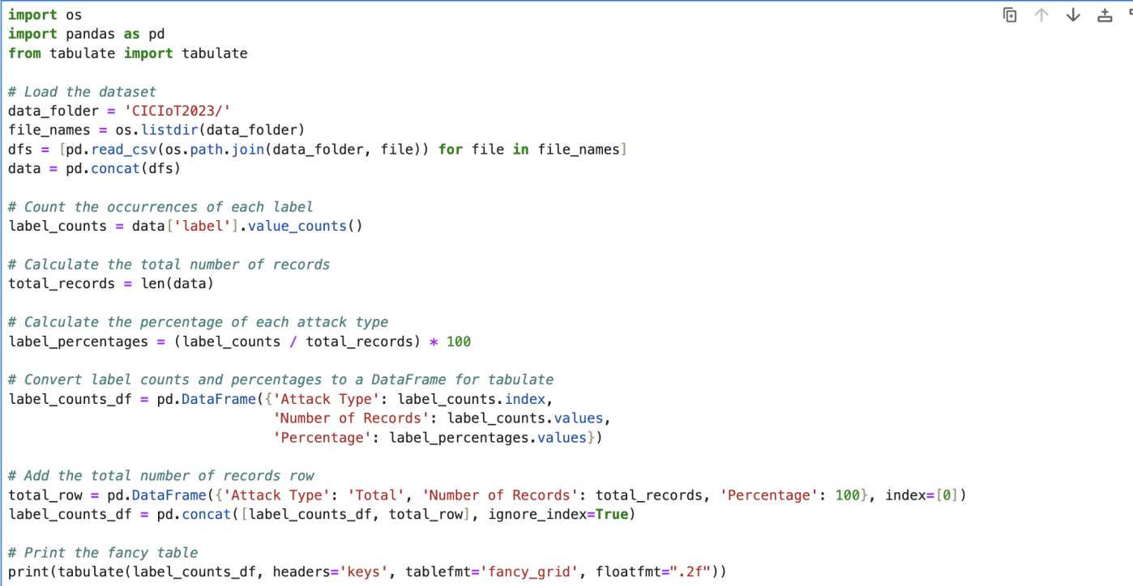

1. Plot of labels for each attack.

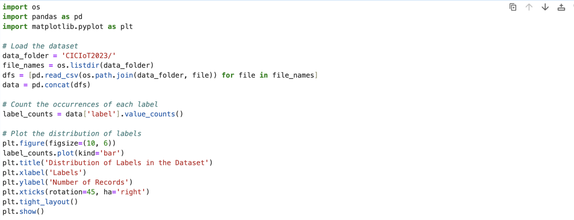

1. Bayesian Model Averaging

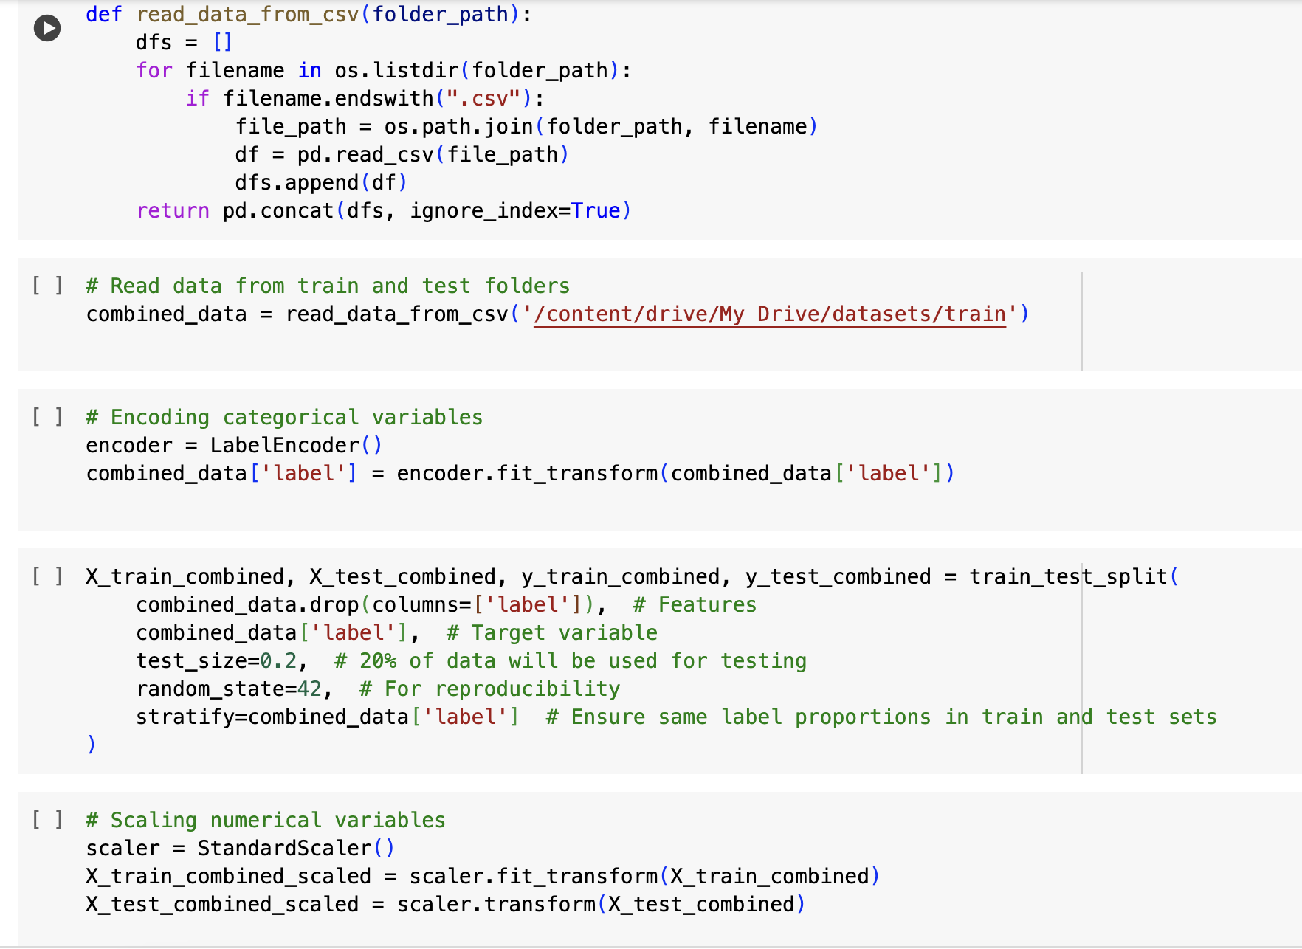

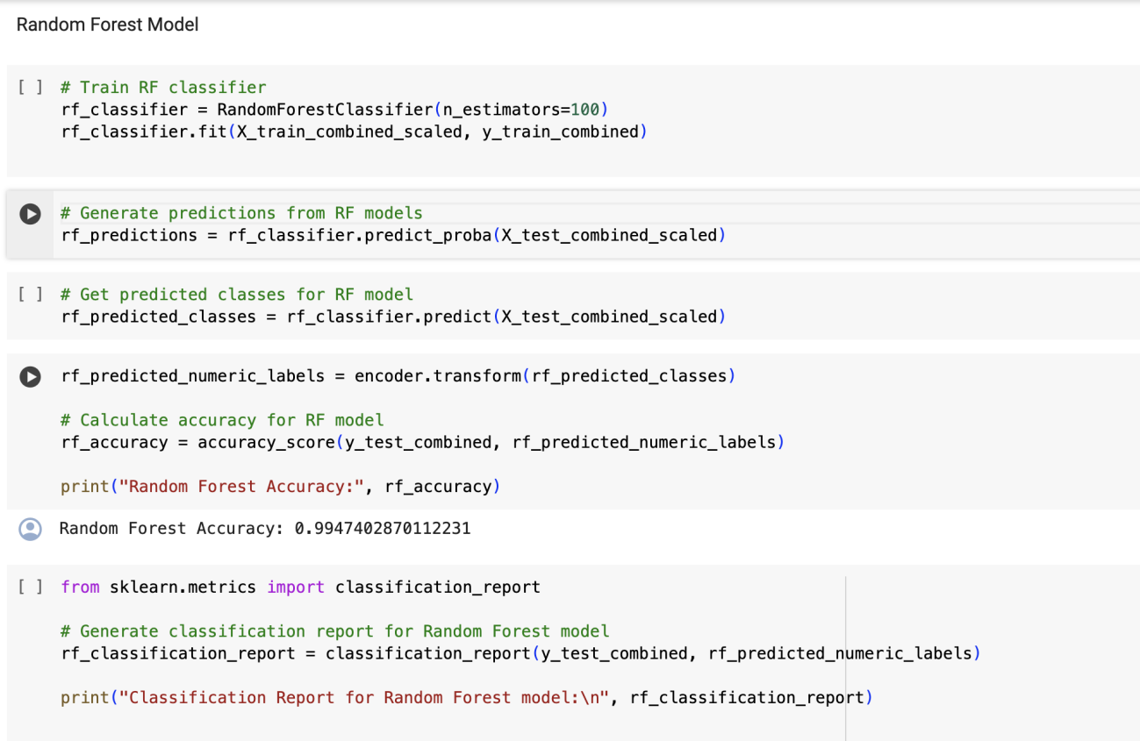

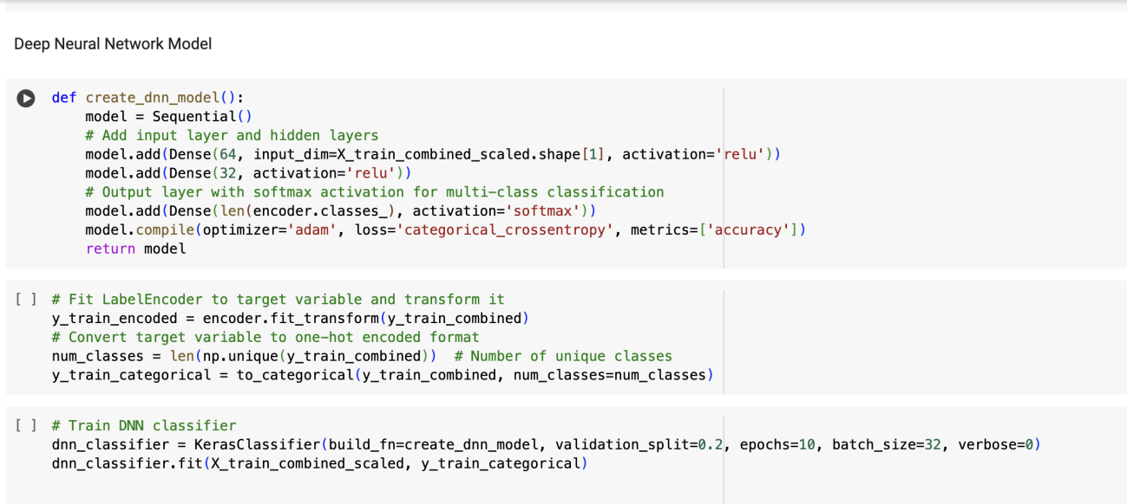

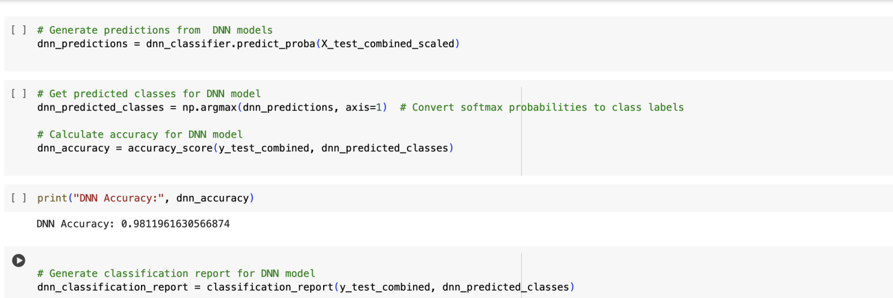

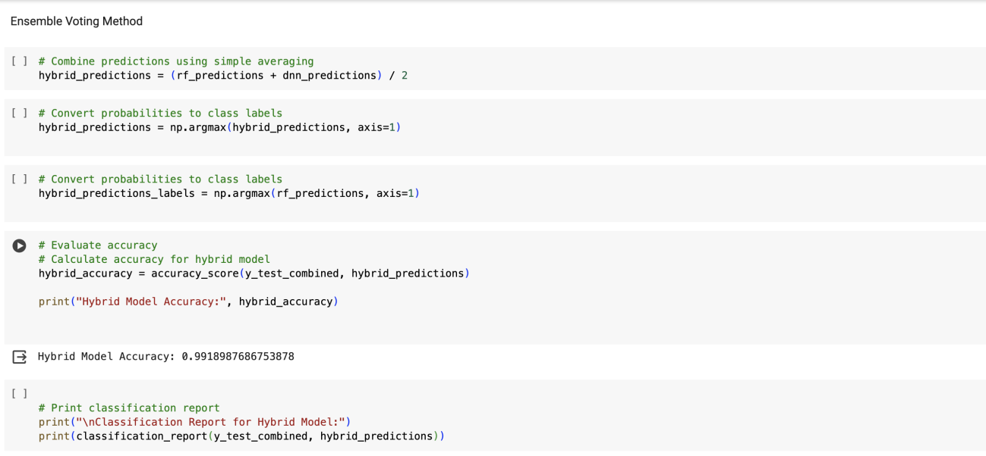

1. Random Subspace Method

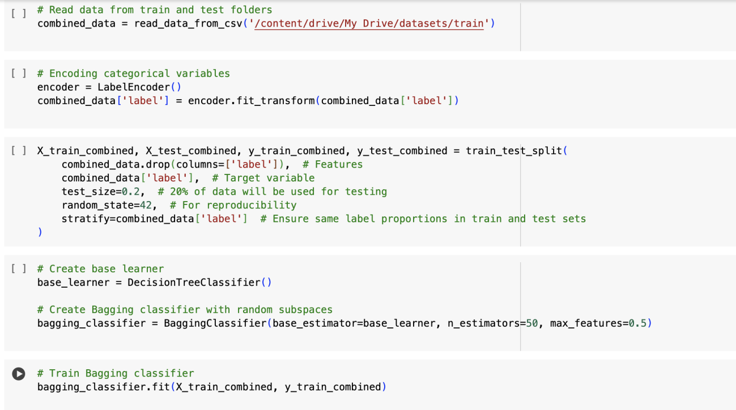

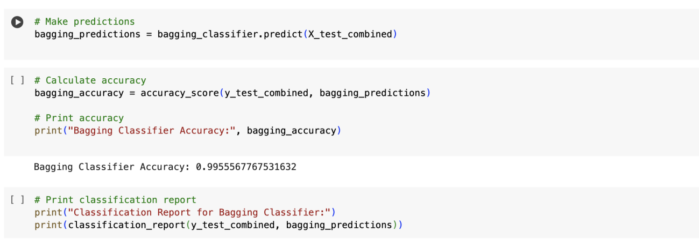

1. Boosting Method

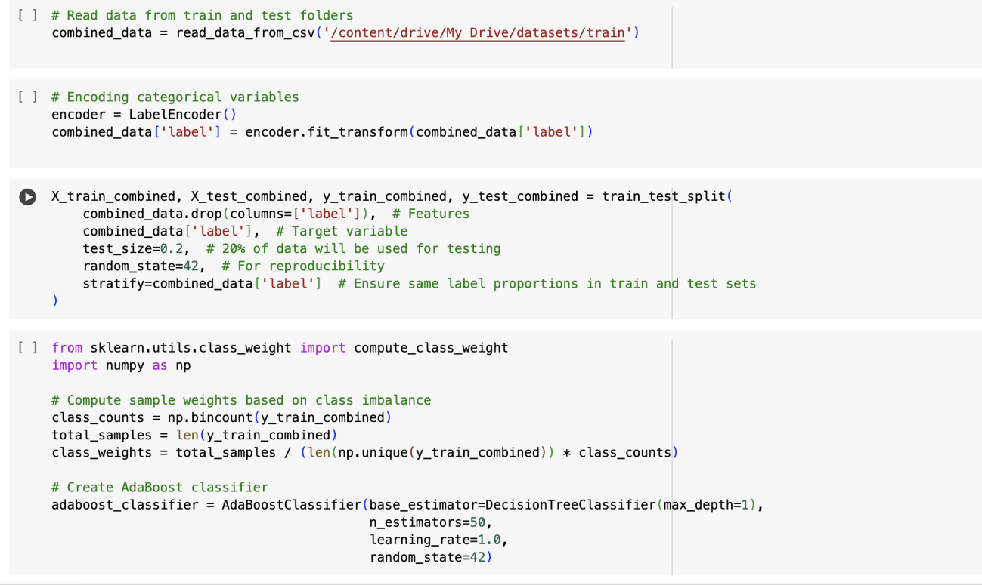

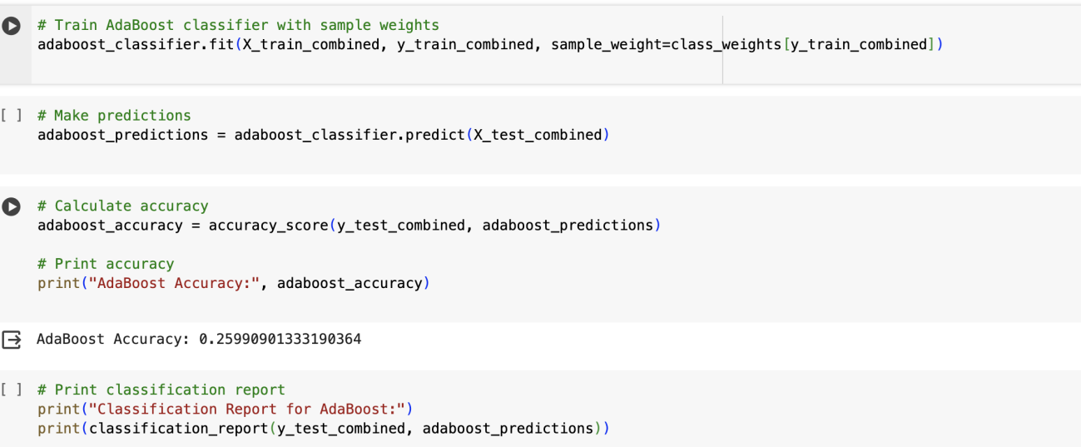

1. Ensemble voting method

